WHITE COUNTY BOARD OF COMMISSIONERS
MINUTES OF THE CALLED MEETING HELD
THURSDAY, JUNE 20, 2024 AT 9:00 A.M.
The White County Board of Commissioners held a Called Meeting on Thursday, June 20, 2022 at 9:00 a.m. in the Board Room at the Administrative Building. Present for the meeting were: Chairman Travis Turner, Commissioner Terry Goodger, Commissioner Lyn Holcomb, Commissioner Edwin Nix, Commissioner Craig Bryant, County Manager Billy Pittard, Interim Finance Director Rose Kisaalita, and County Clerk Shanda Murphy.
Chairman Turner called the meeting to order.
Mr. Pittard made the following presentation:

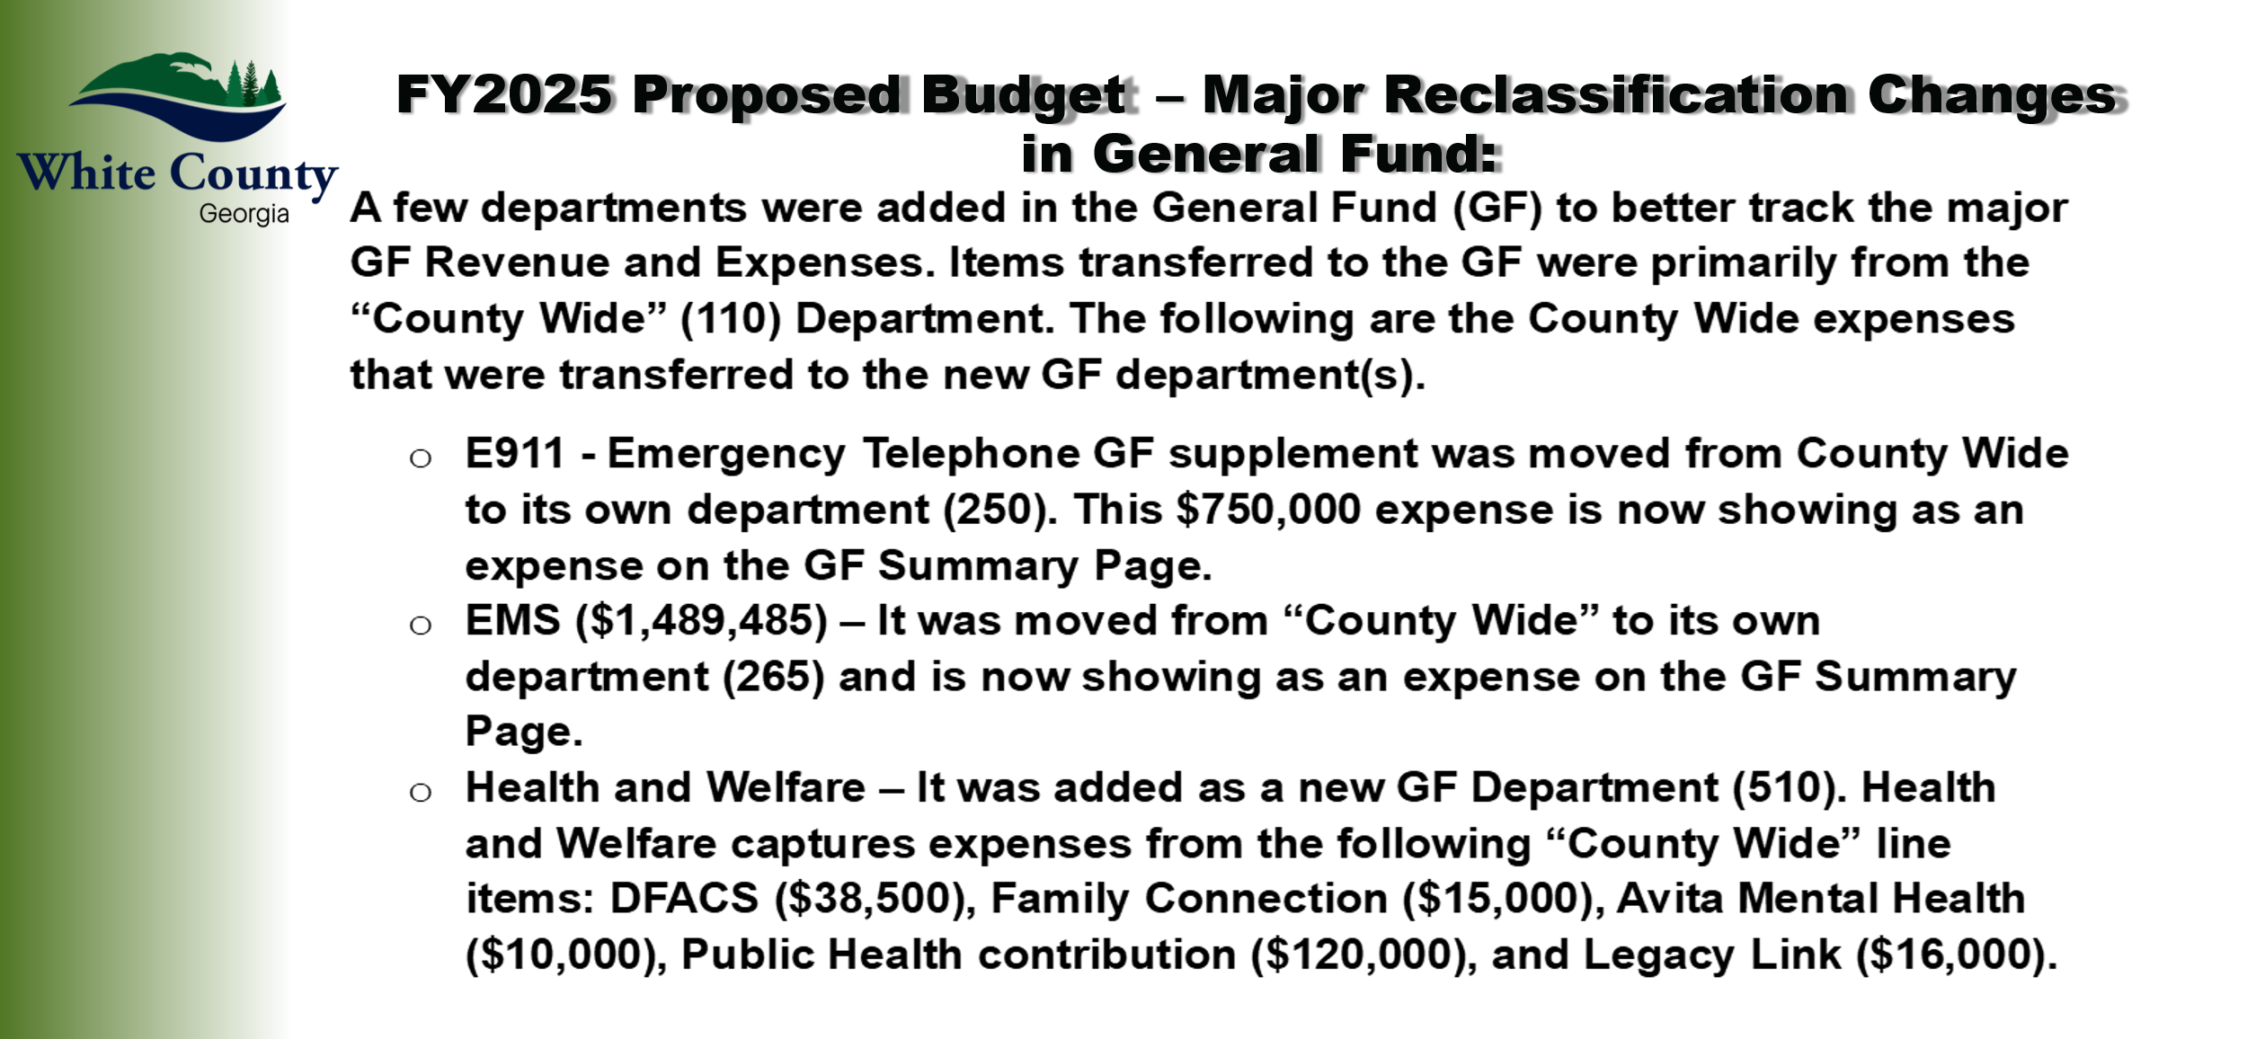
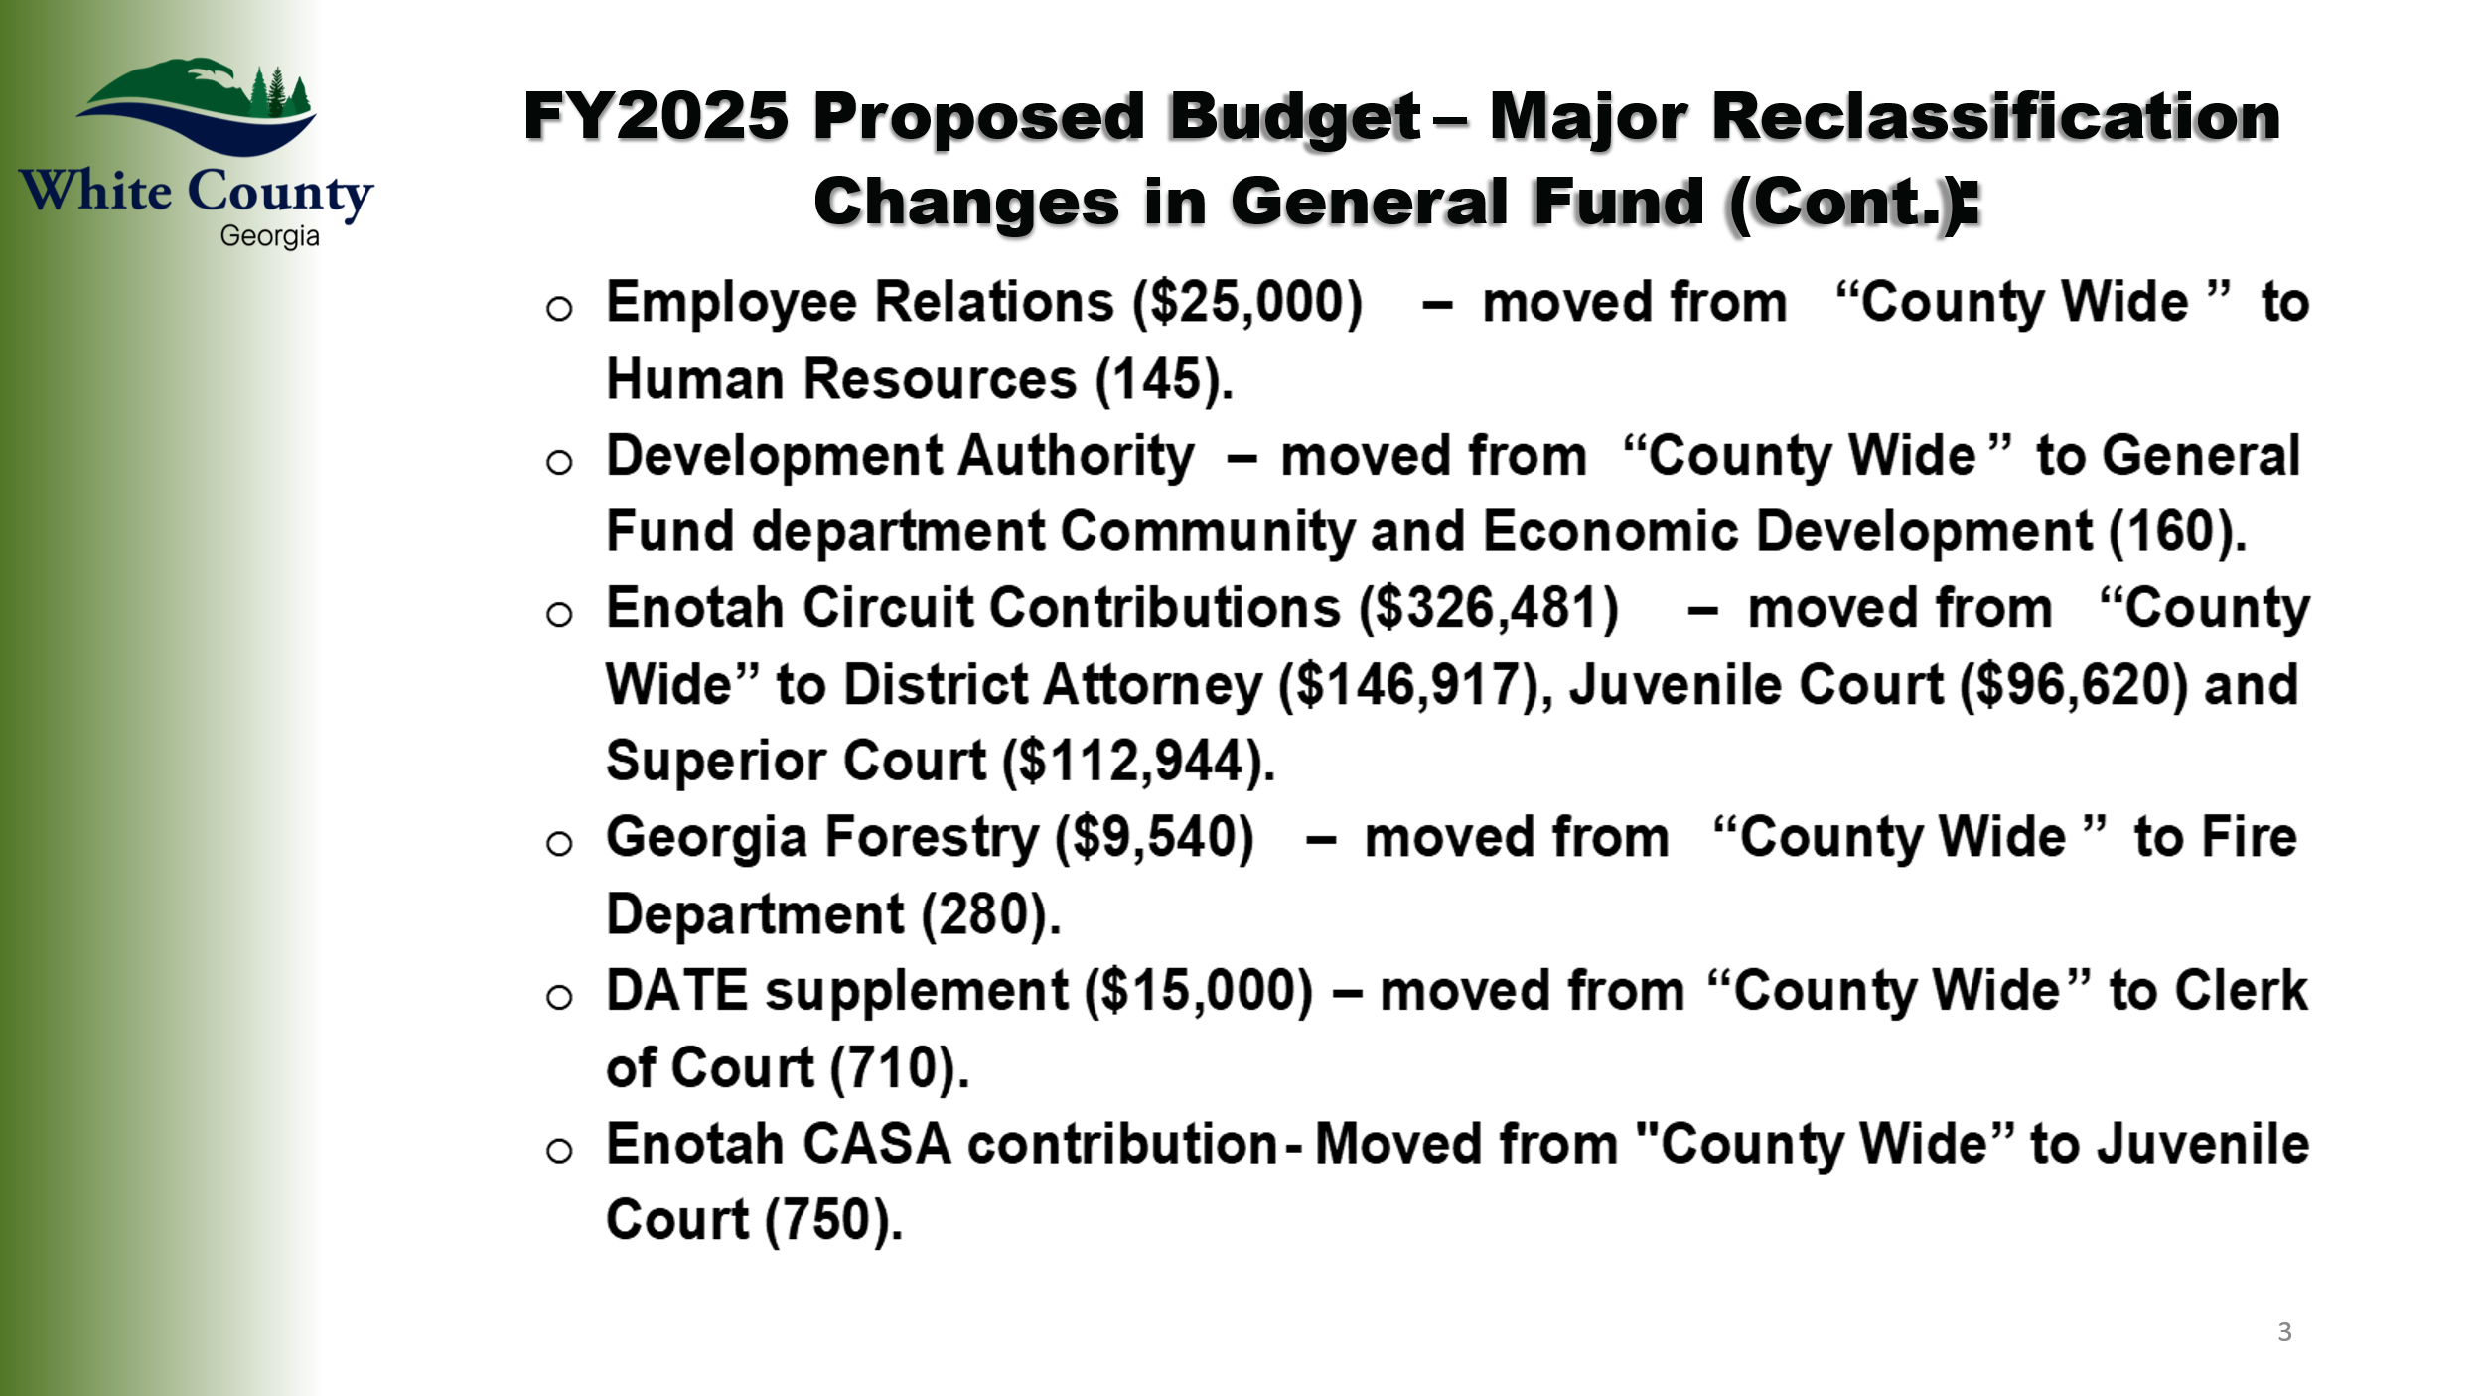
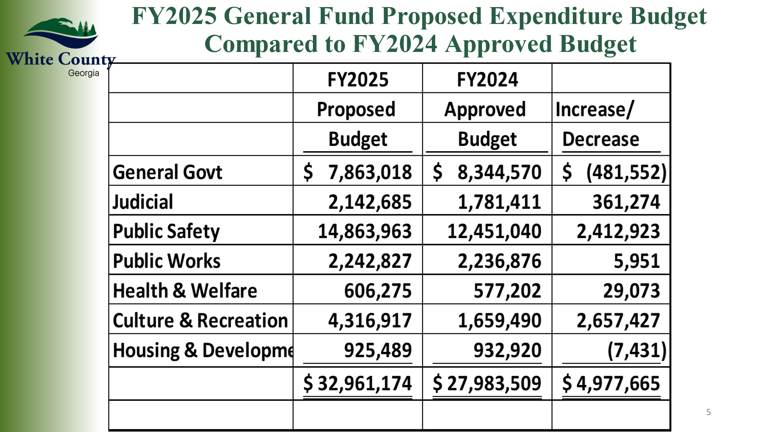
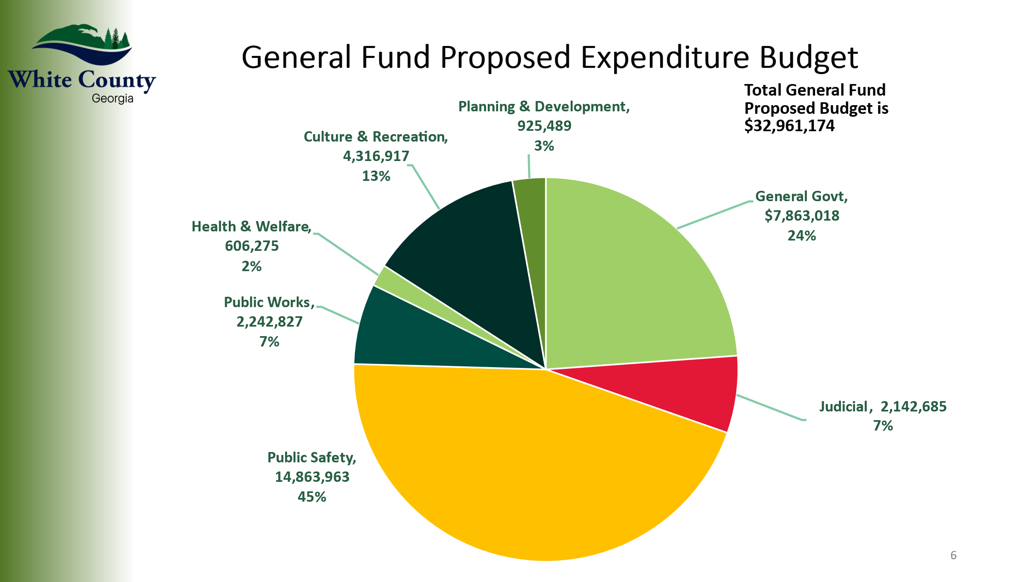
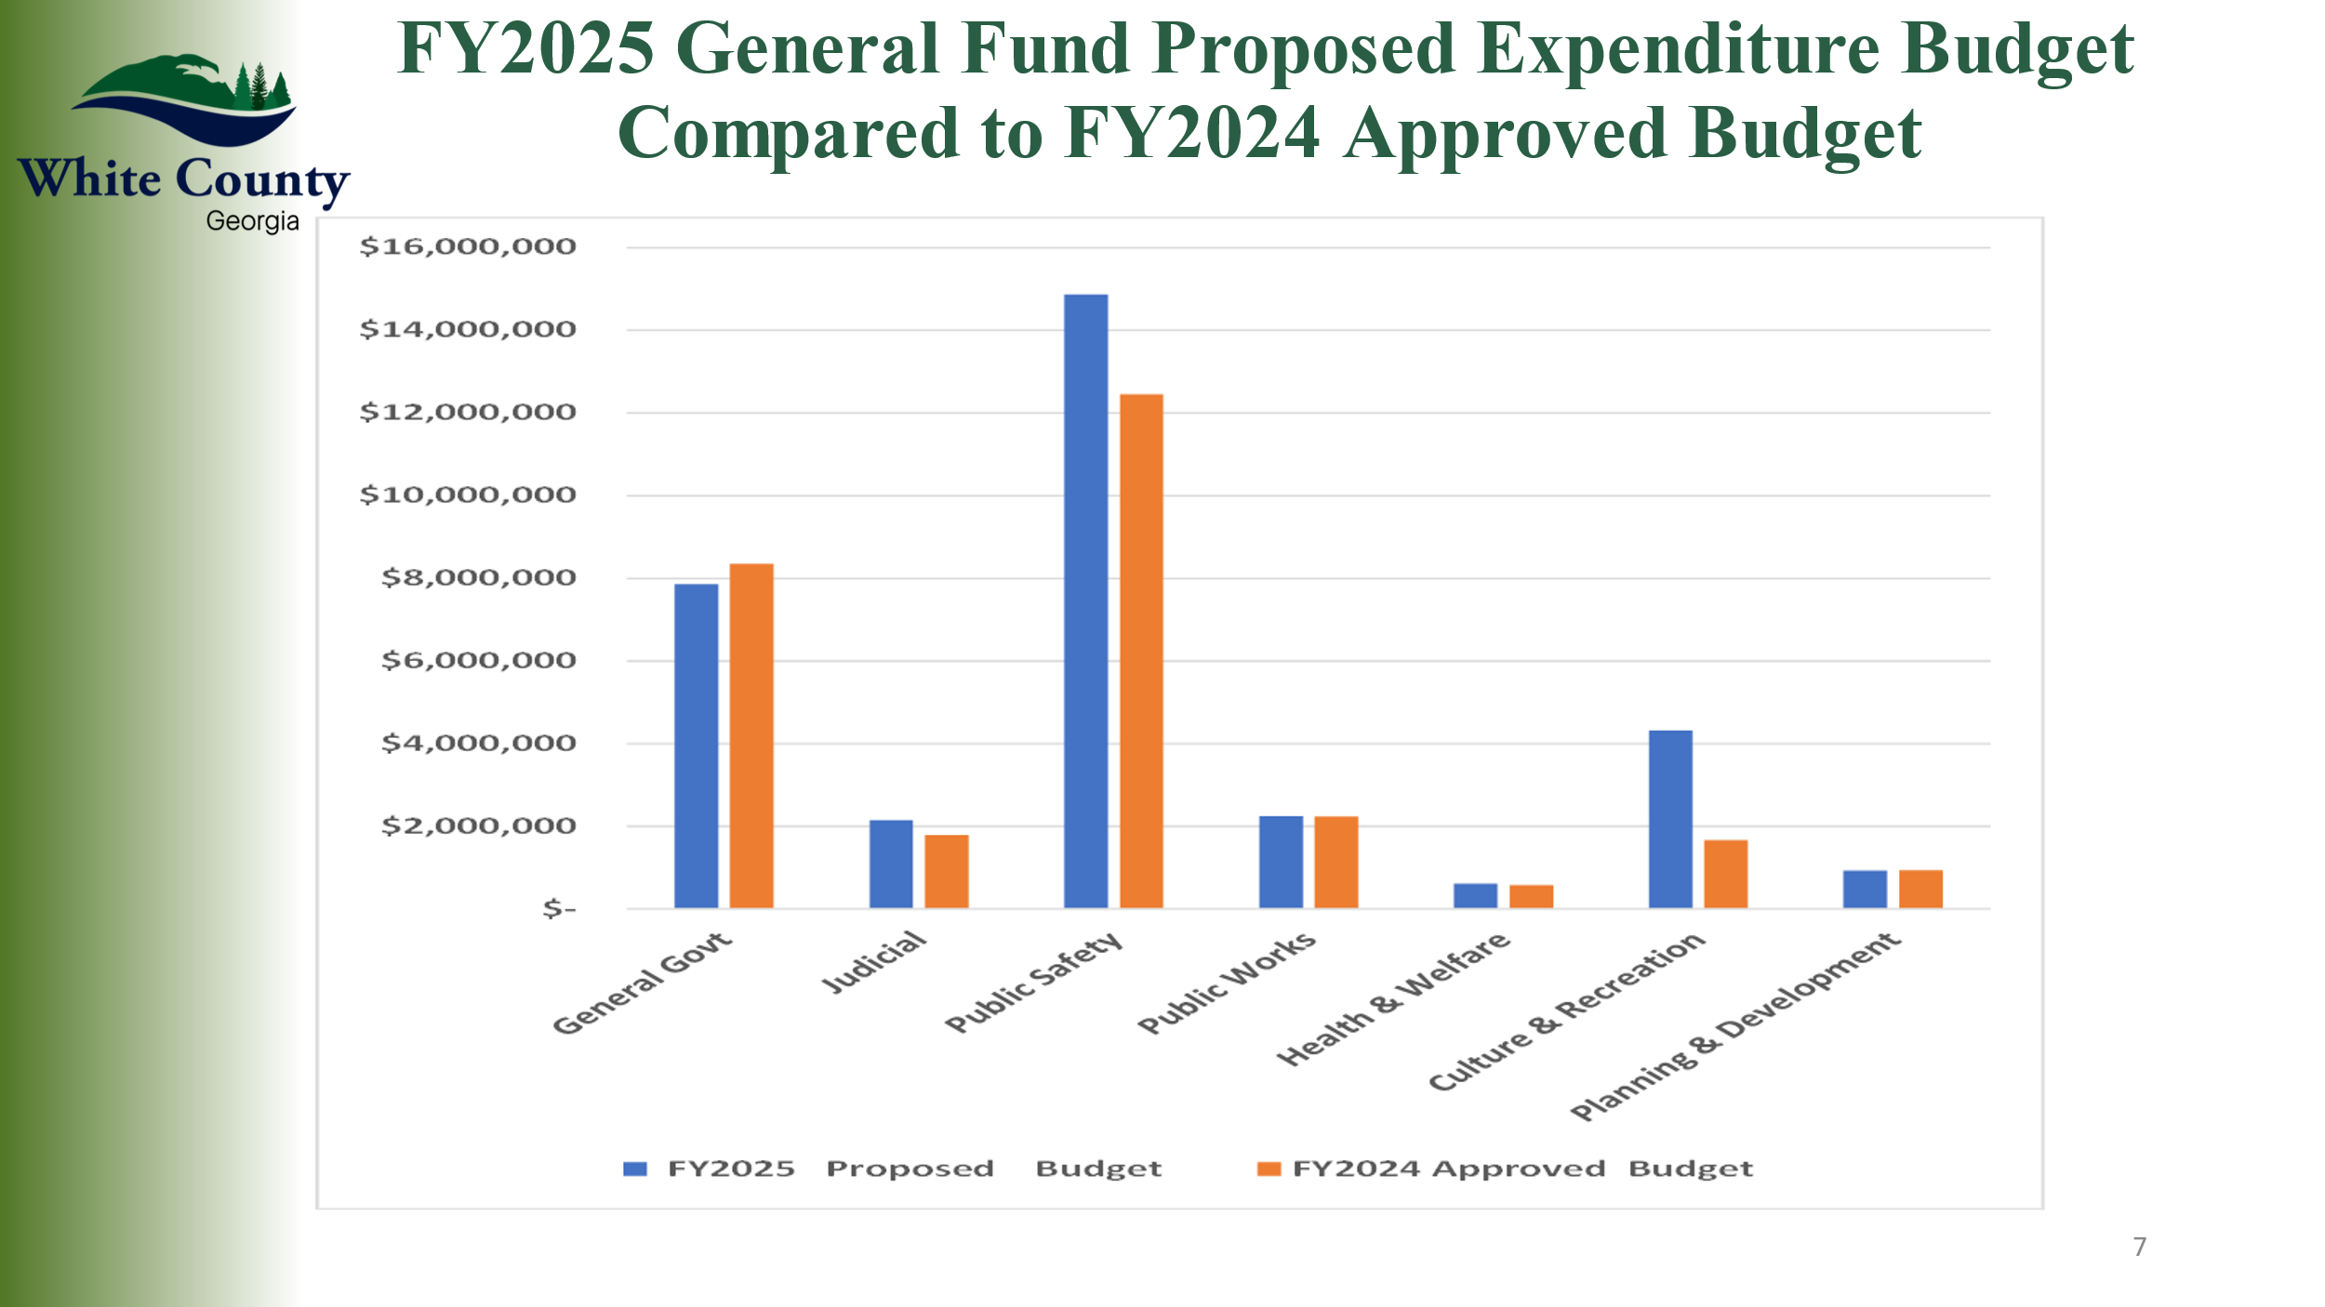
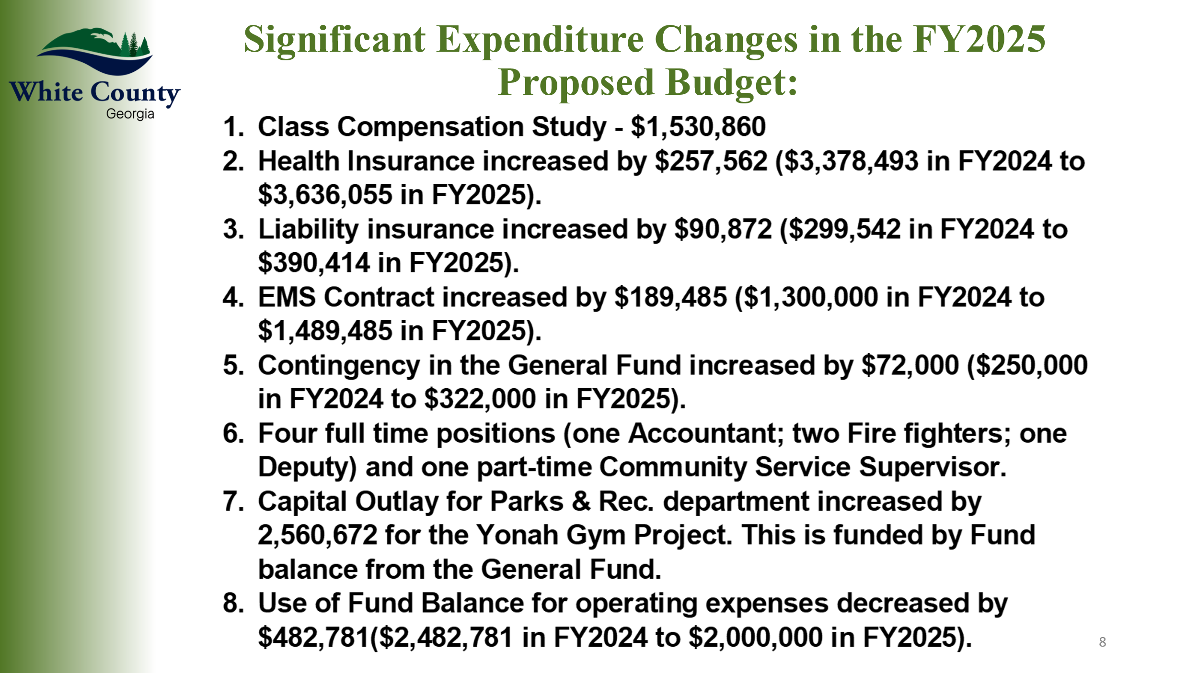
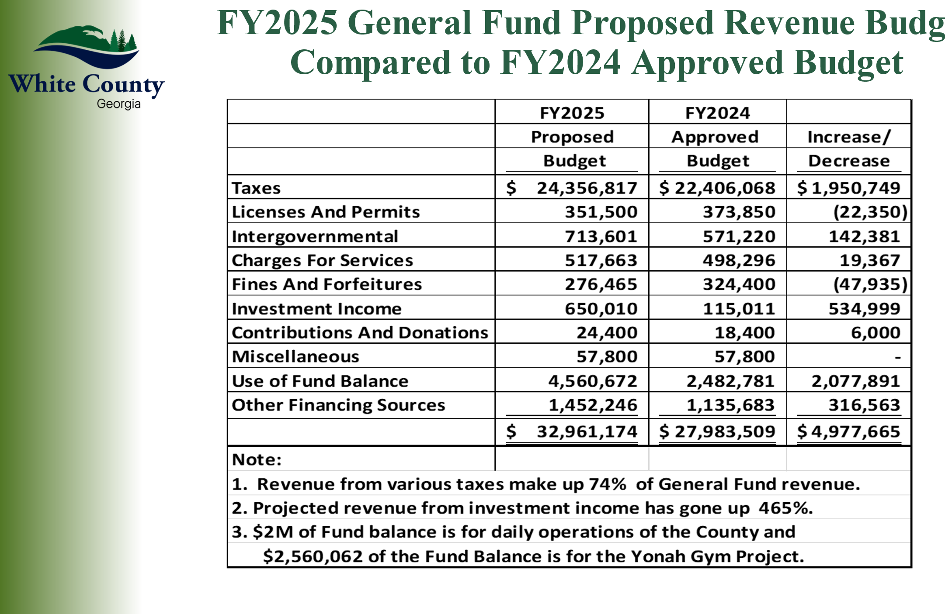
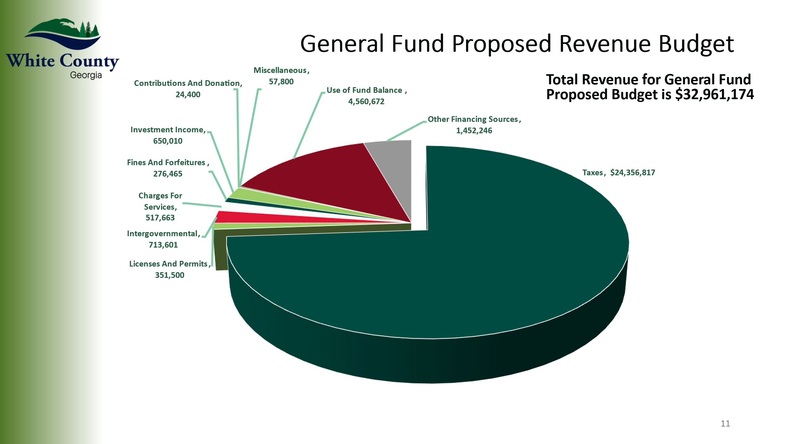
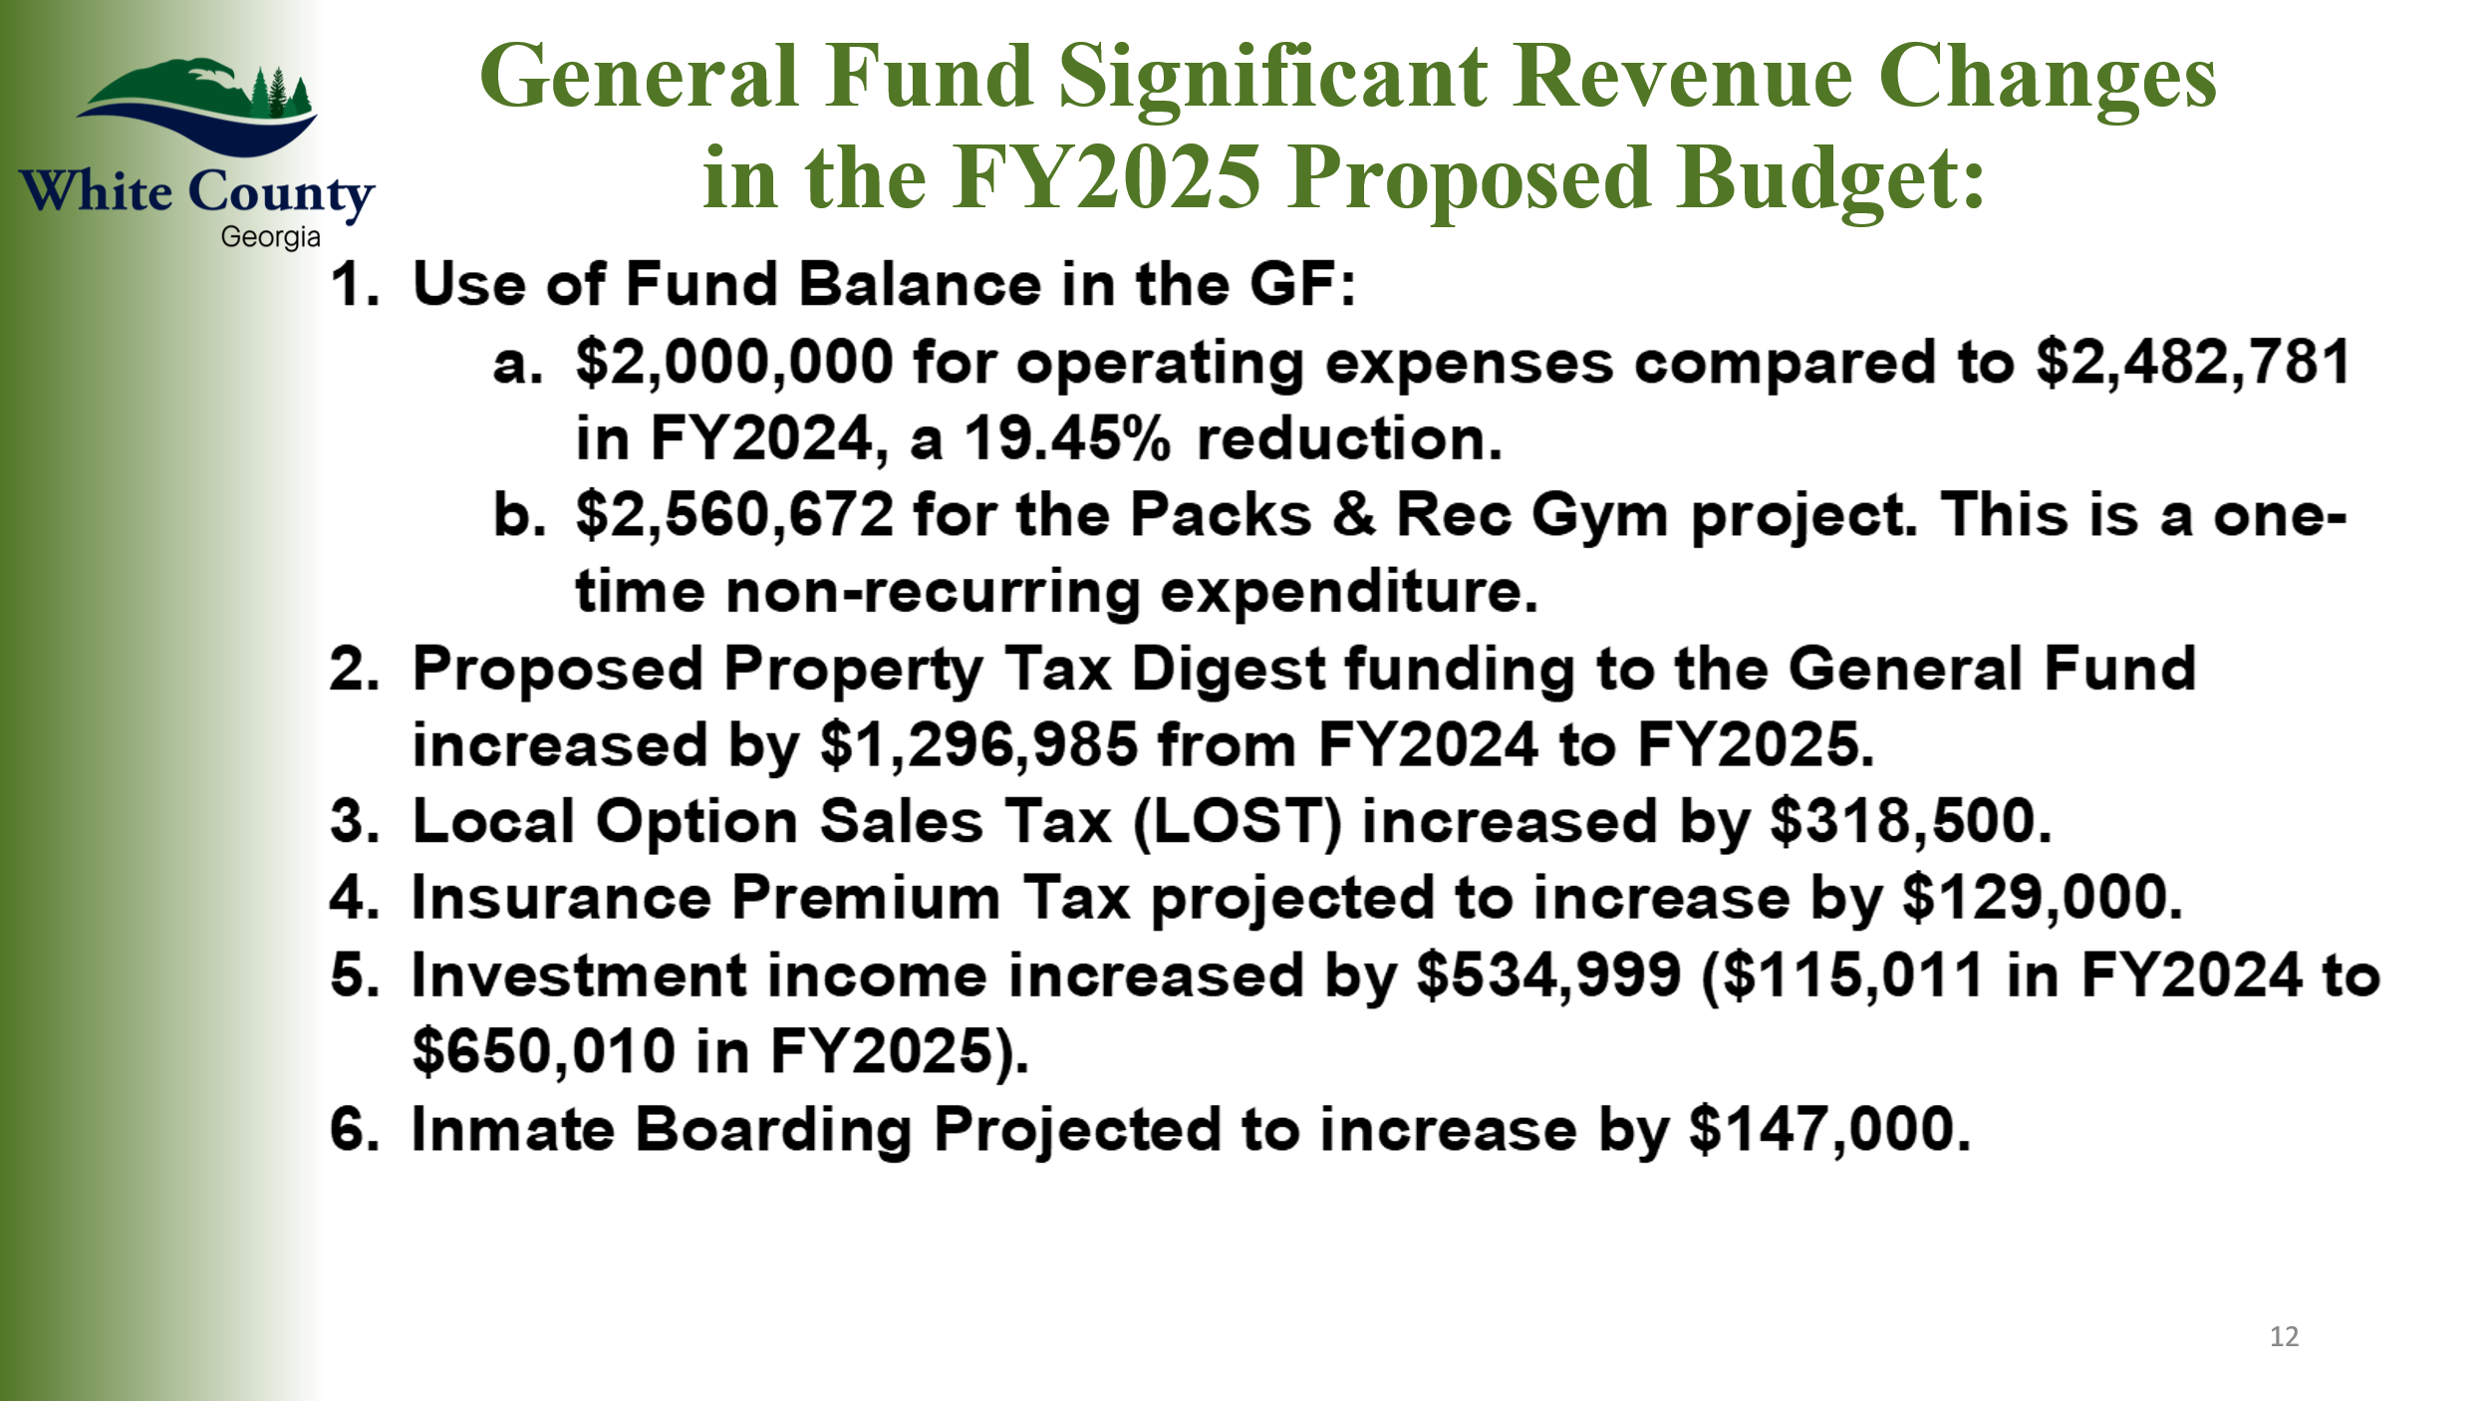
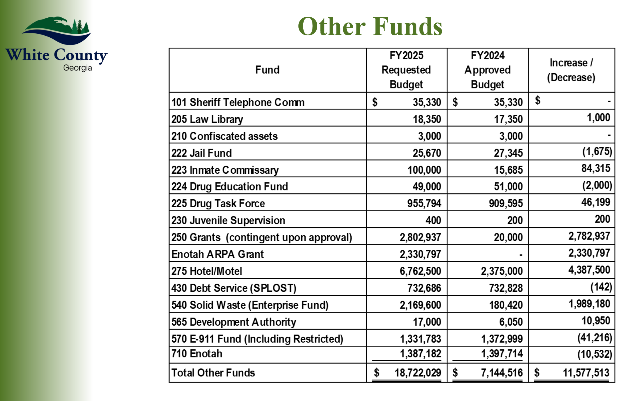
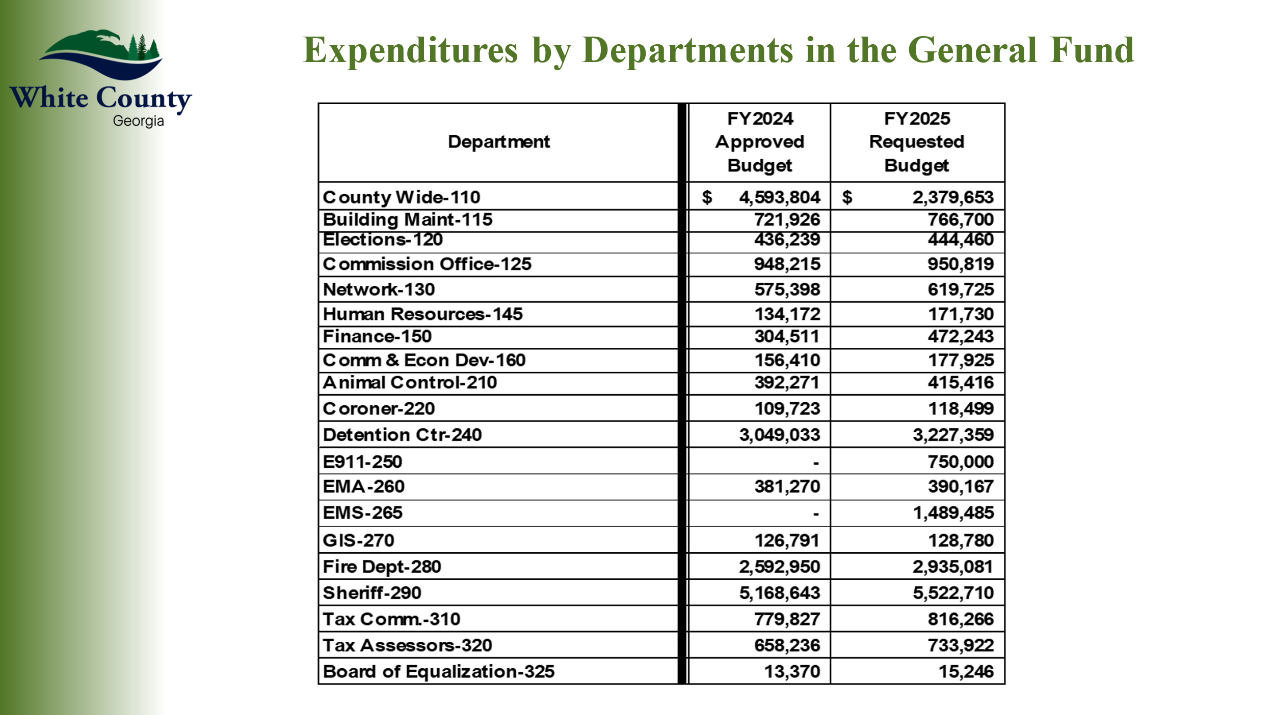
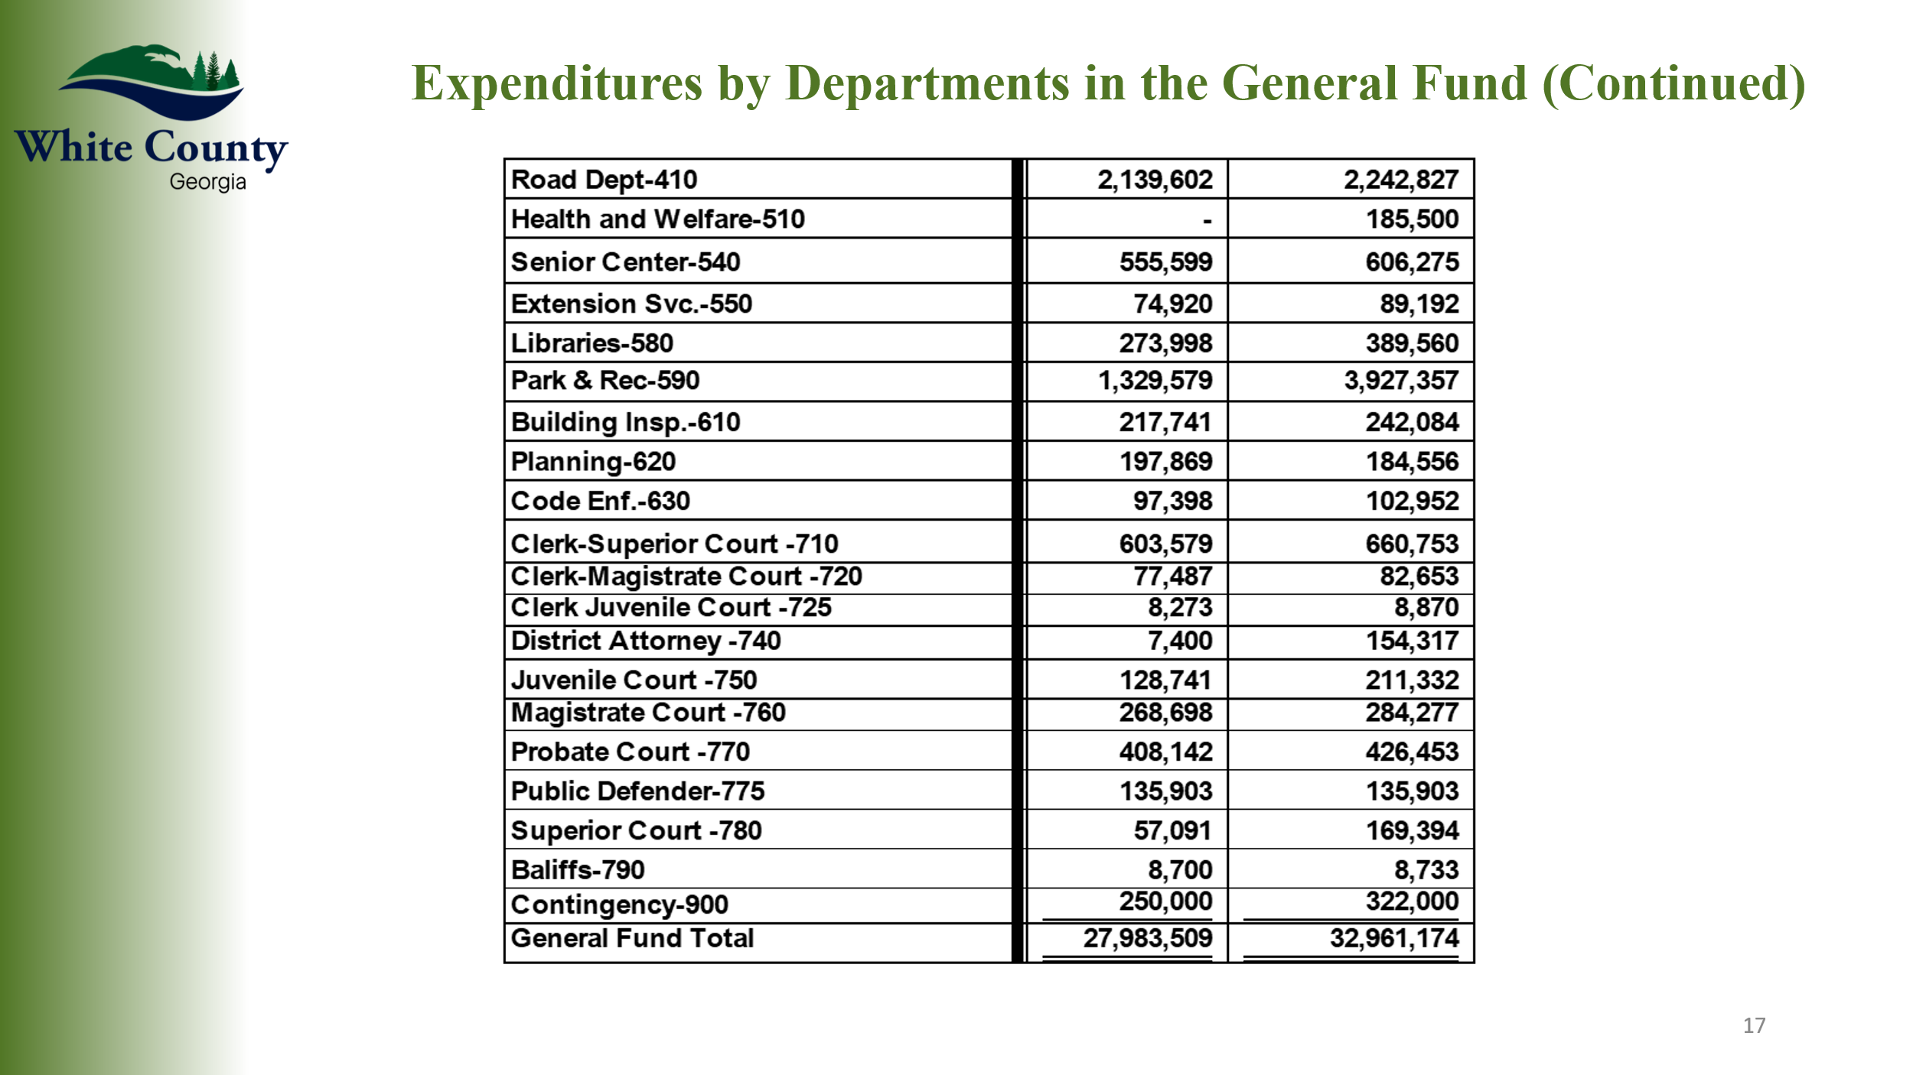
* End of Presentation *
Mr. Pittard stated that several expenses which had been previously shown in Department 125 (Countywide), had been reclassified to a more appropriate department within the budget being presented. He also noted that there was a one-time $2,560,672.00 expense in the General Fund Budget (590 Parks & Recreation) for the gym construction project, which was generated from the General Fund / Fund Balance. Mr. Pittard also reviewed the Separate Funds, stating that since a significant amount of that fund’s, fund balance ($4,387,500.00) would be used for the gym construction project, this amount is included as both a revenue and expense within the Hotel / Motel Tax Fund – therefore the numbers associated with this fund are much higher than the actual revenues and expenses anticipated. He also reviewed that the Solid Waste Fund had increased significantly due revenue now coming to the County since the County has assumed the operations for the Transfer Station, which were previously contracted to Waste Management. He also advised that the increase in the Inmate Commissary Fund was due to the planned purchase of a body scanner for the jail.
Chairman Turner expressed his appreciation to Mr. Pittard, Ms. Kisaalita, Ms. Murphy, County Department Heads, and Elected Officials for the effort they all put into developing the FY 25 Budget.
Mr. Pittard also expressed his appreciation to Ms. Rose Kisaalita, the Elected Officials, and County Department Heads for their hard work on developing the FY 2025 Budget being presented.
Upon a motion made by Commissioner Goodger, seconded by Commissioner Nix there was a unanimous vote to adopt County Resolution 2024-11, approving the Fiscal Year 2024-2025 Budget for White County.
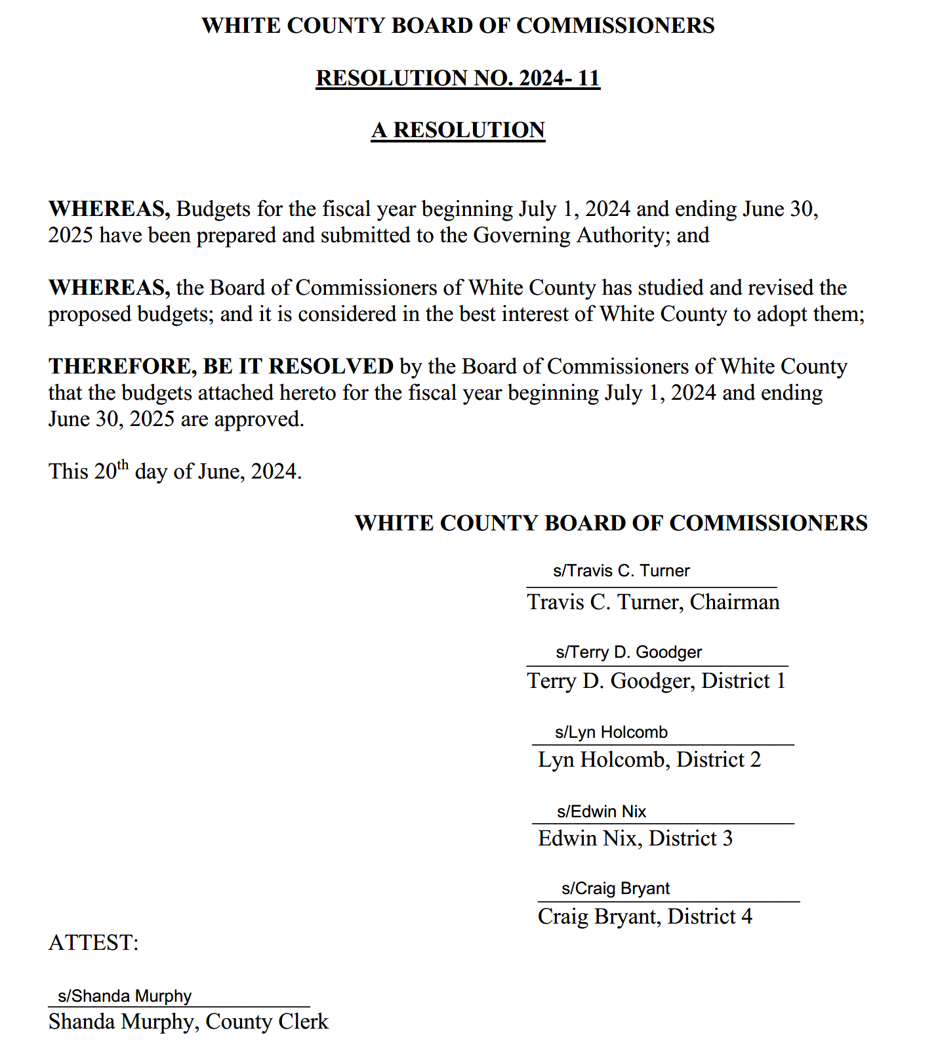
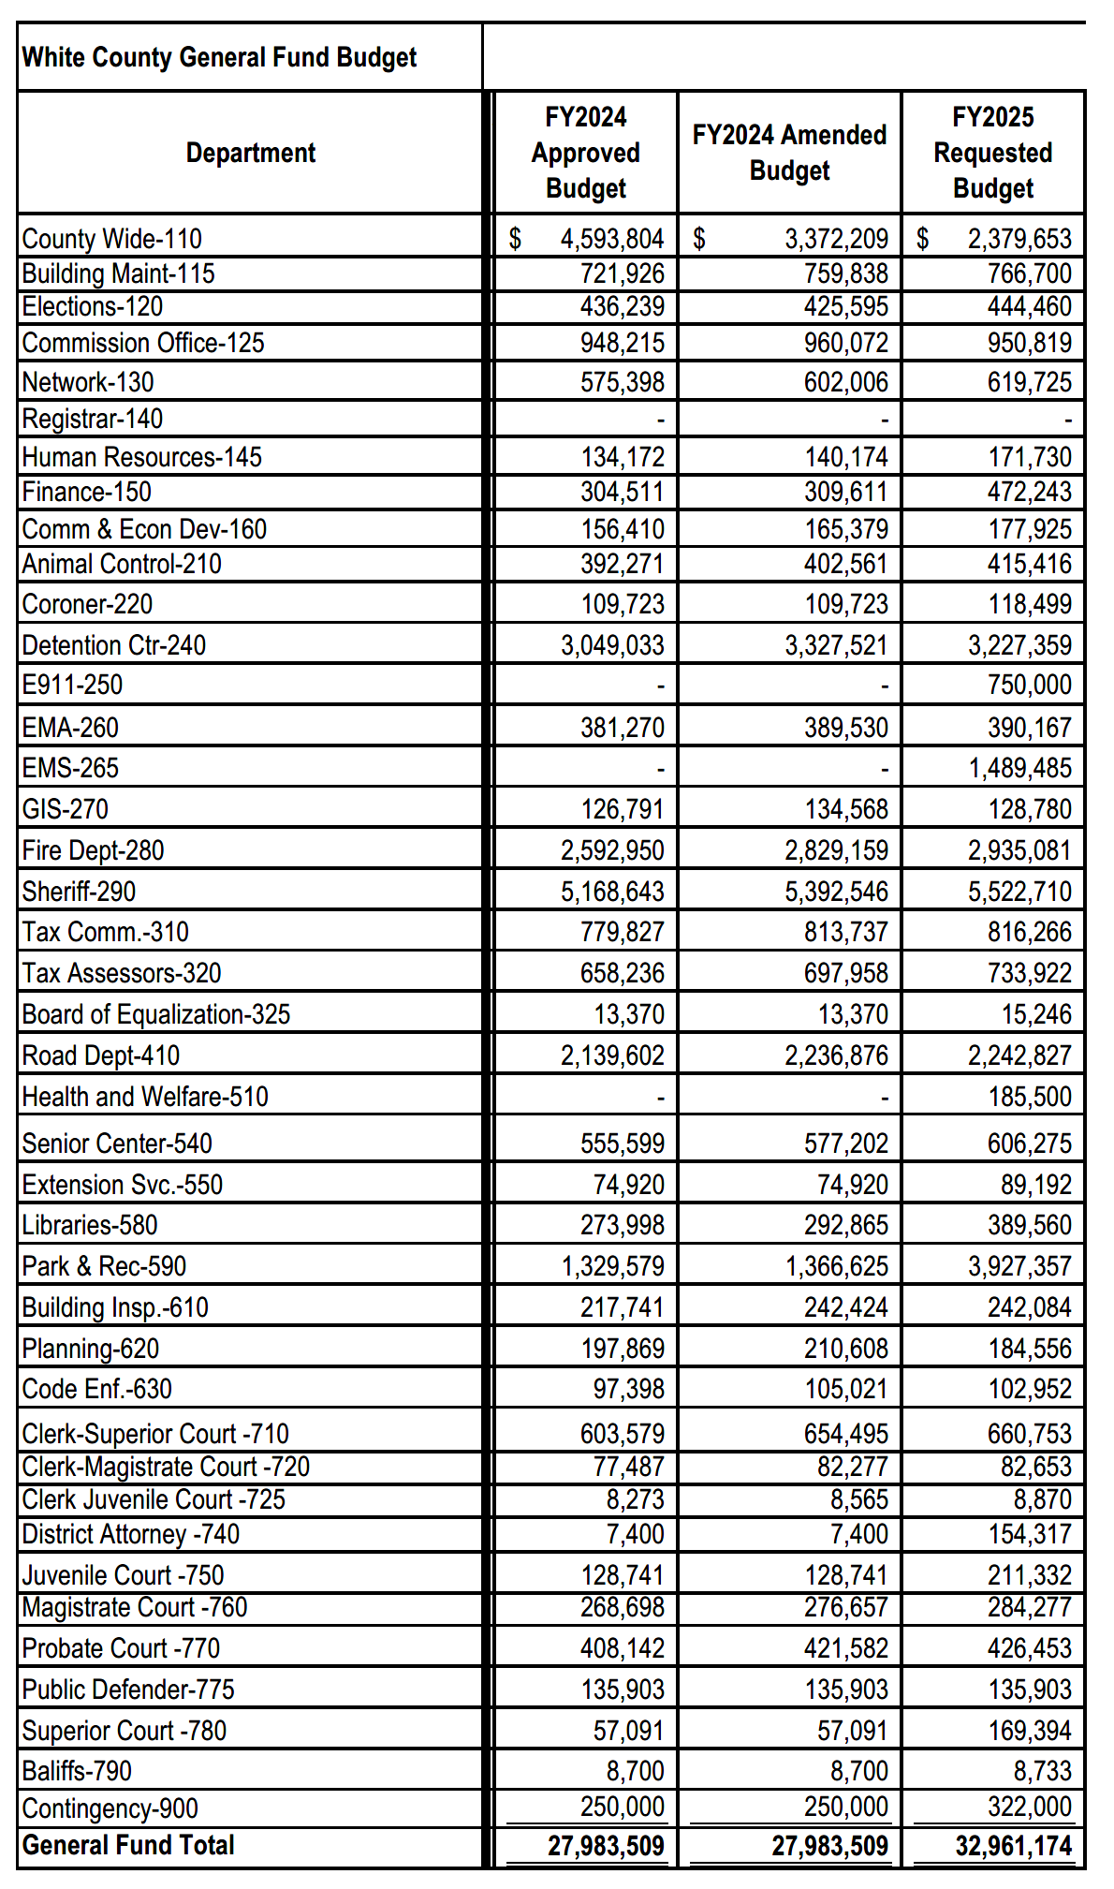
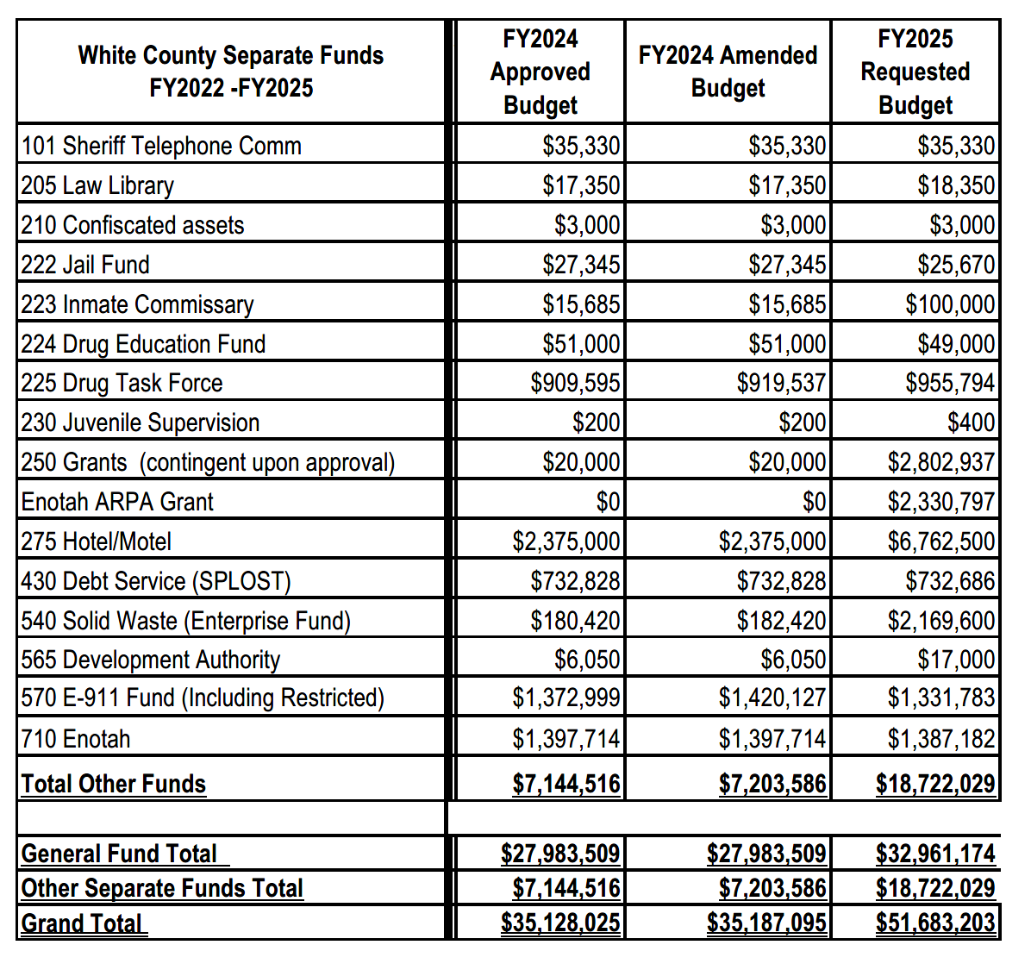
* End of Resolution No. 2024-11*
Upon a motion made by Commissioner Nix, seconded by Commissioner Bryant there was a unanimous vote to adjourn the meeting.
The minutes of the June 20, 2024 Called Meeting were approved as stated this 24th day of June, 2024.

WHITE COUNTY BOARD OF COMMISSIONERS
s/Travis C. Turner
Travis C. Turner, Chairman
s/Terry D. Goodger
Terry D. Goodger, District 1

s/Lyn Holcomb
Lyn Holcomb, District 2

s/Edwin Nix
Edwin Nix, District 3

s/Craig Bryant
Craig Bryant, District 4
s/Shanda Murphy
Shanda Murphy, County Clerk

