**WHITE COUNTY BOARD OF COMMISSIONERS**

**MINUTES OF THE FY 2025 BUDGET PUBLIC HEARING**

**HELD THURSDAY, JUNE 13, 2024 AT 4:30 P.M.**

On Thursday, June 13, 2024 at 4:30 p.m., the White County Board of Commissioners held a public hearing on the proposed FY 2025 Budget in the Board Room at the Administration Building. Present for the meeting were: Chairman Travis Turner, Commissioner Terry Goodger, Commissioner Lyn Holcomb, Commissioner Edwin Nix, Commissioner Craig Bryant, County Manager Billy Pittard, Interim Finance Director Rose Kisaalita, and County Clerk Shanda Murphy.

Chairman Turner called the meeting to order.

Mr. Pittard made the following presentation:

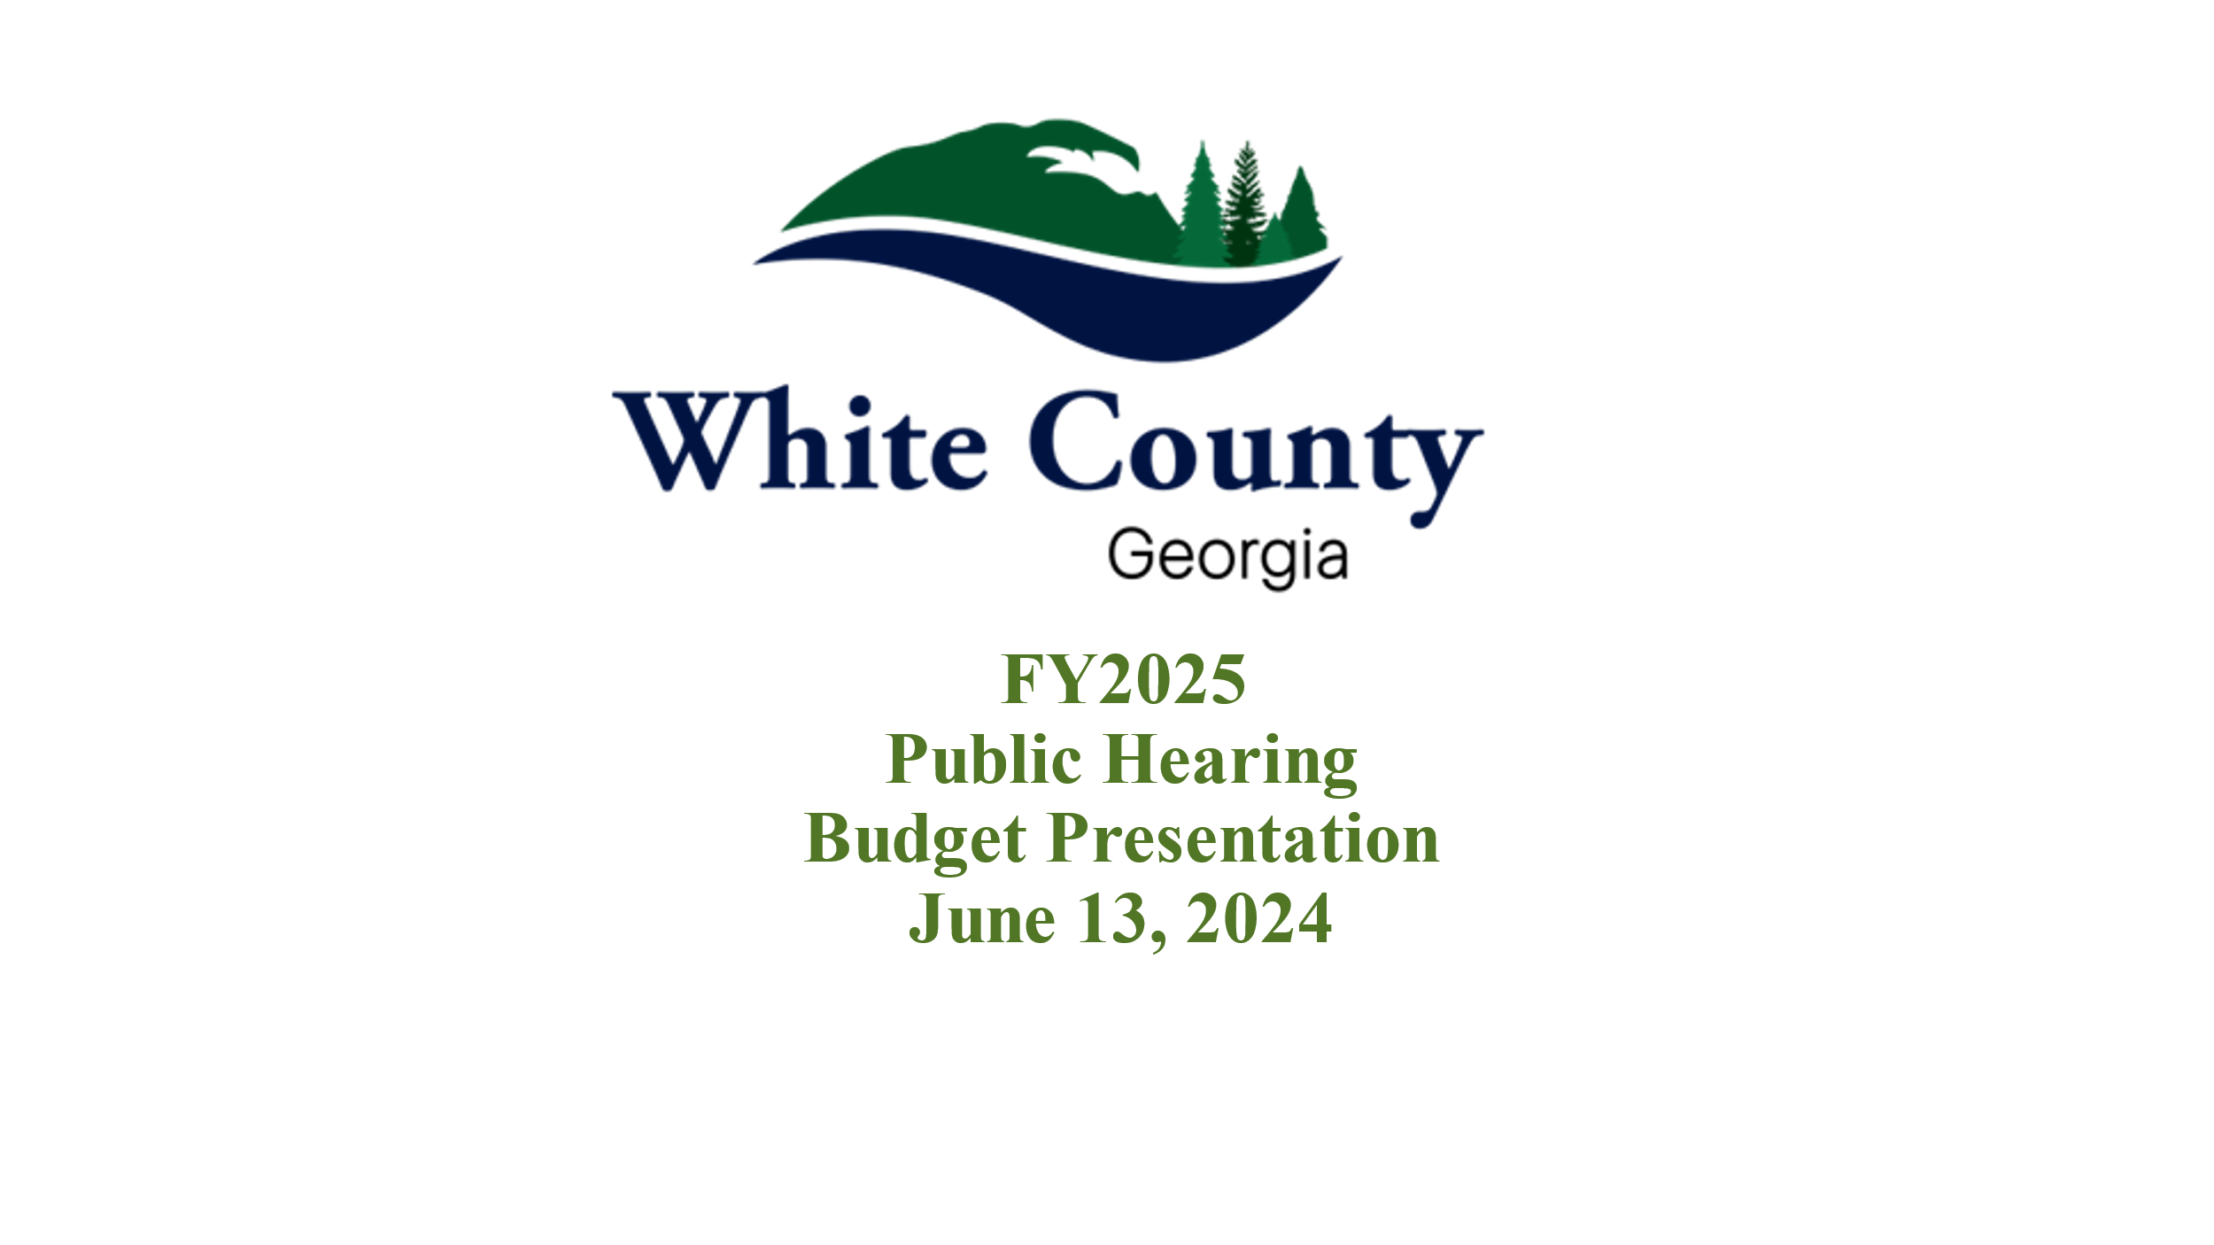

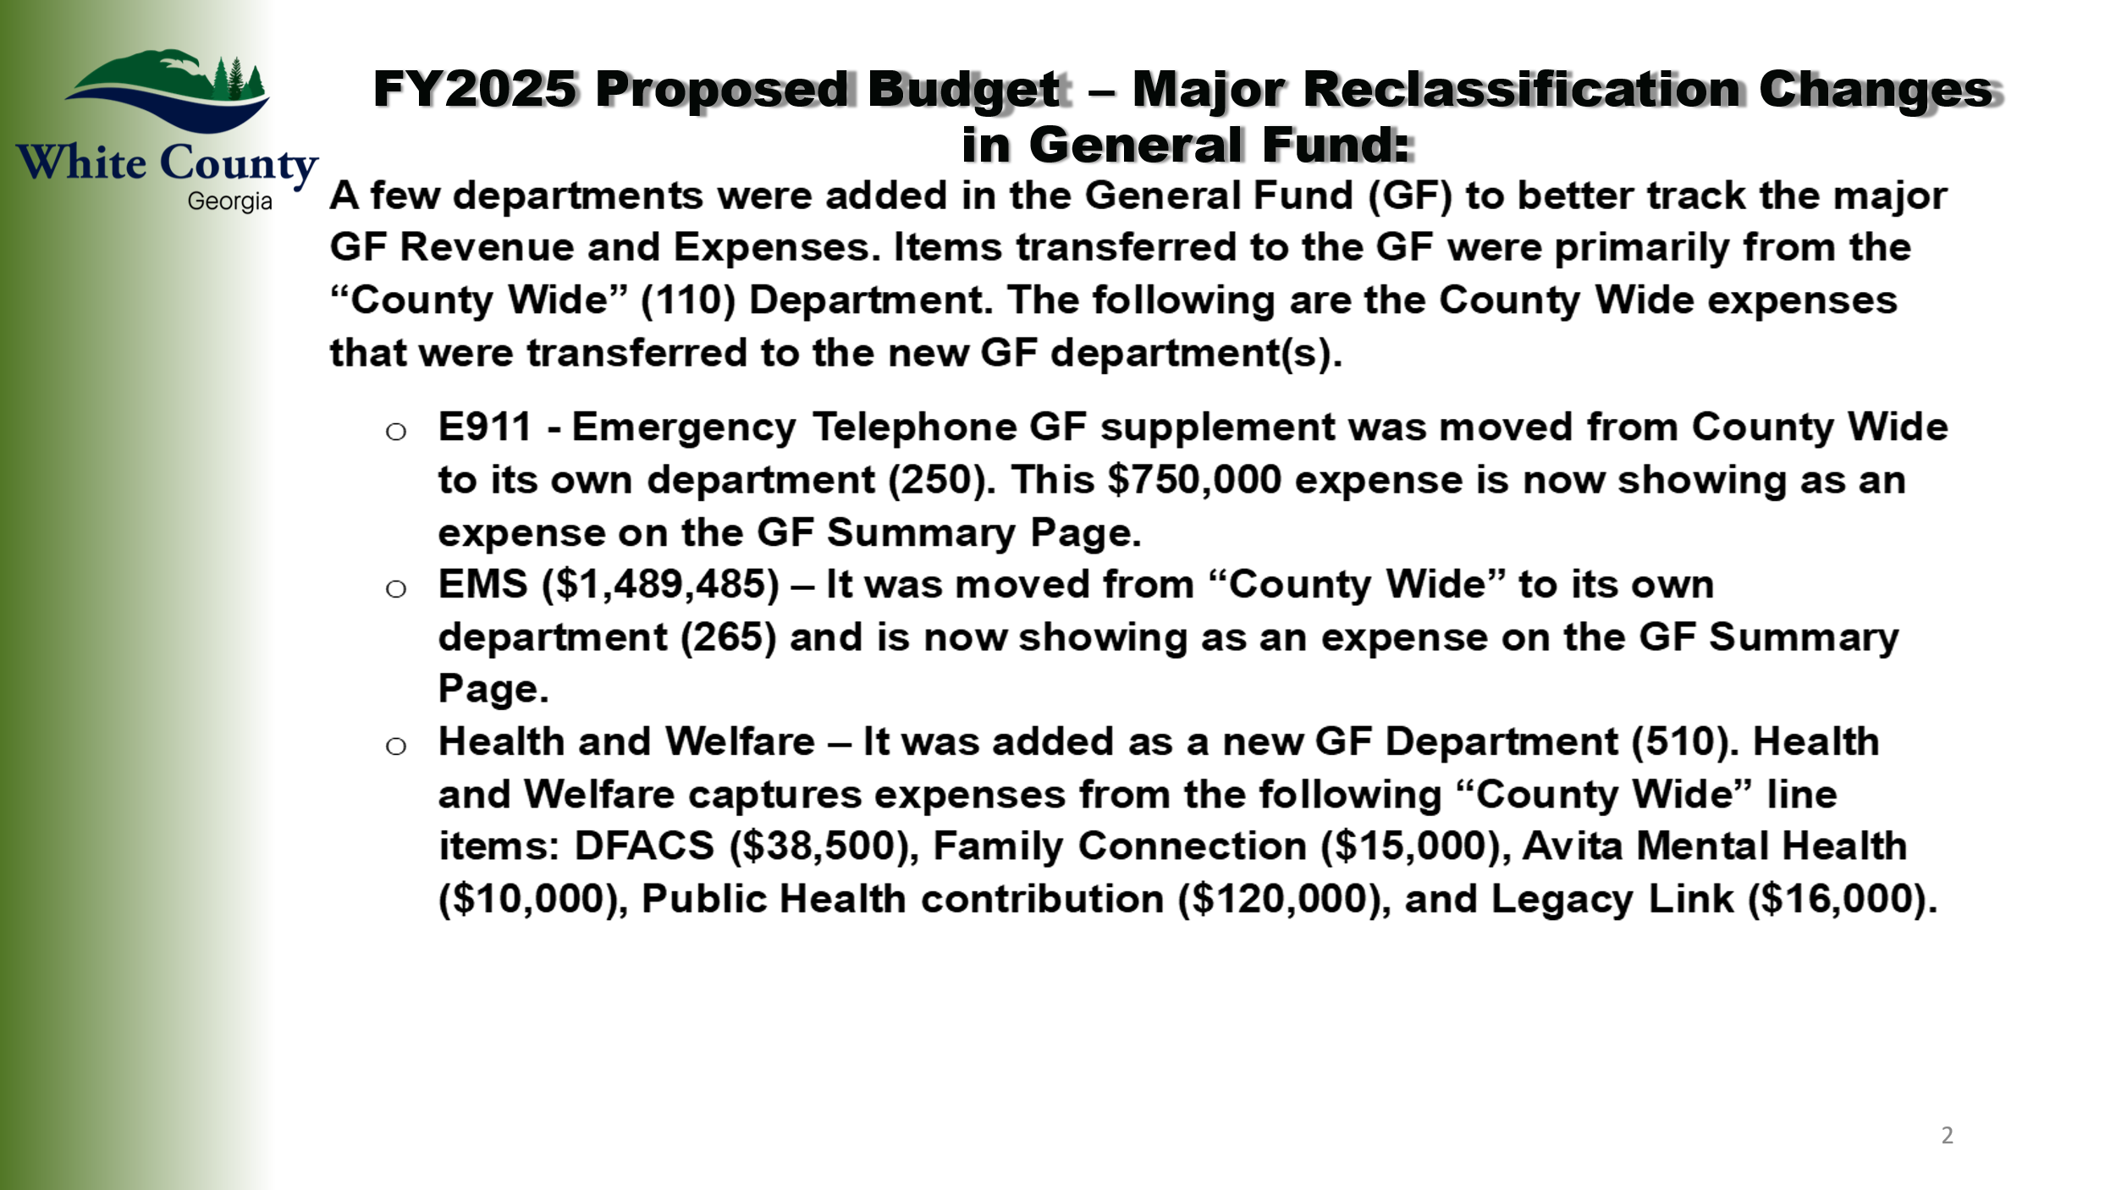

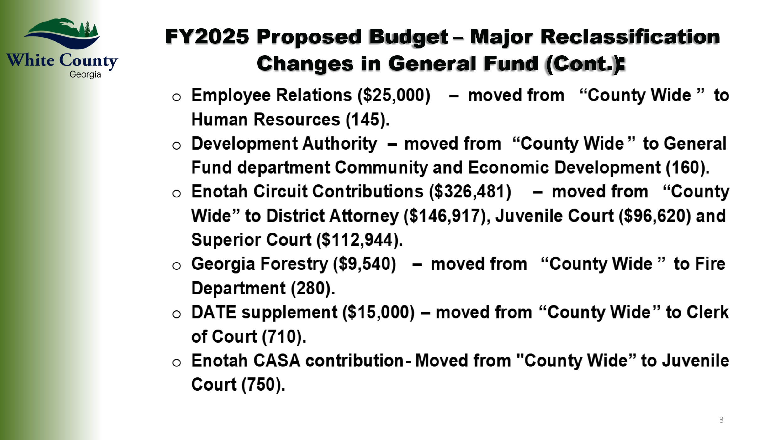

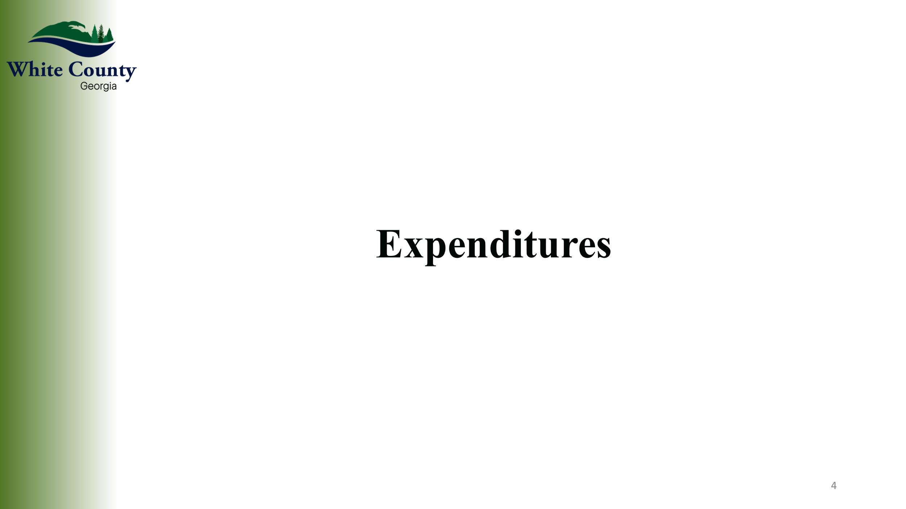  
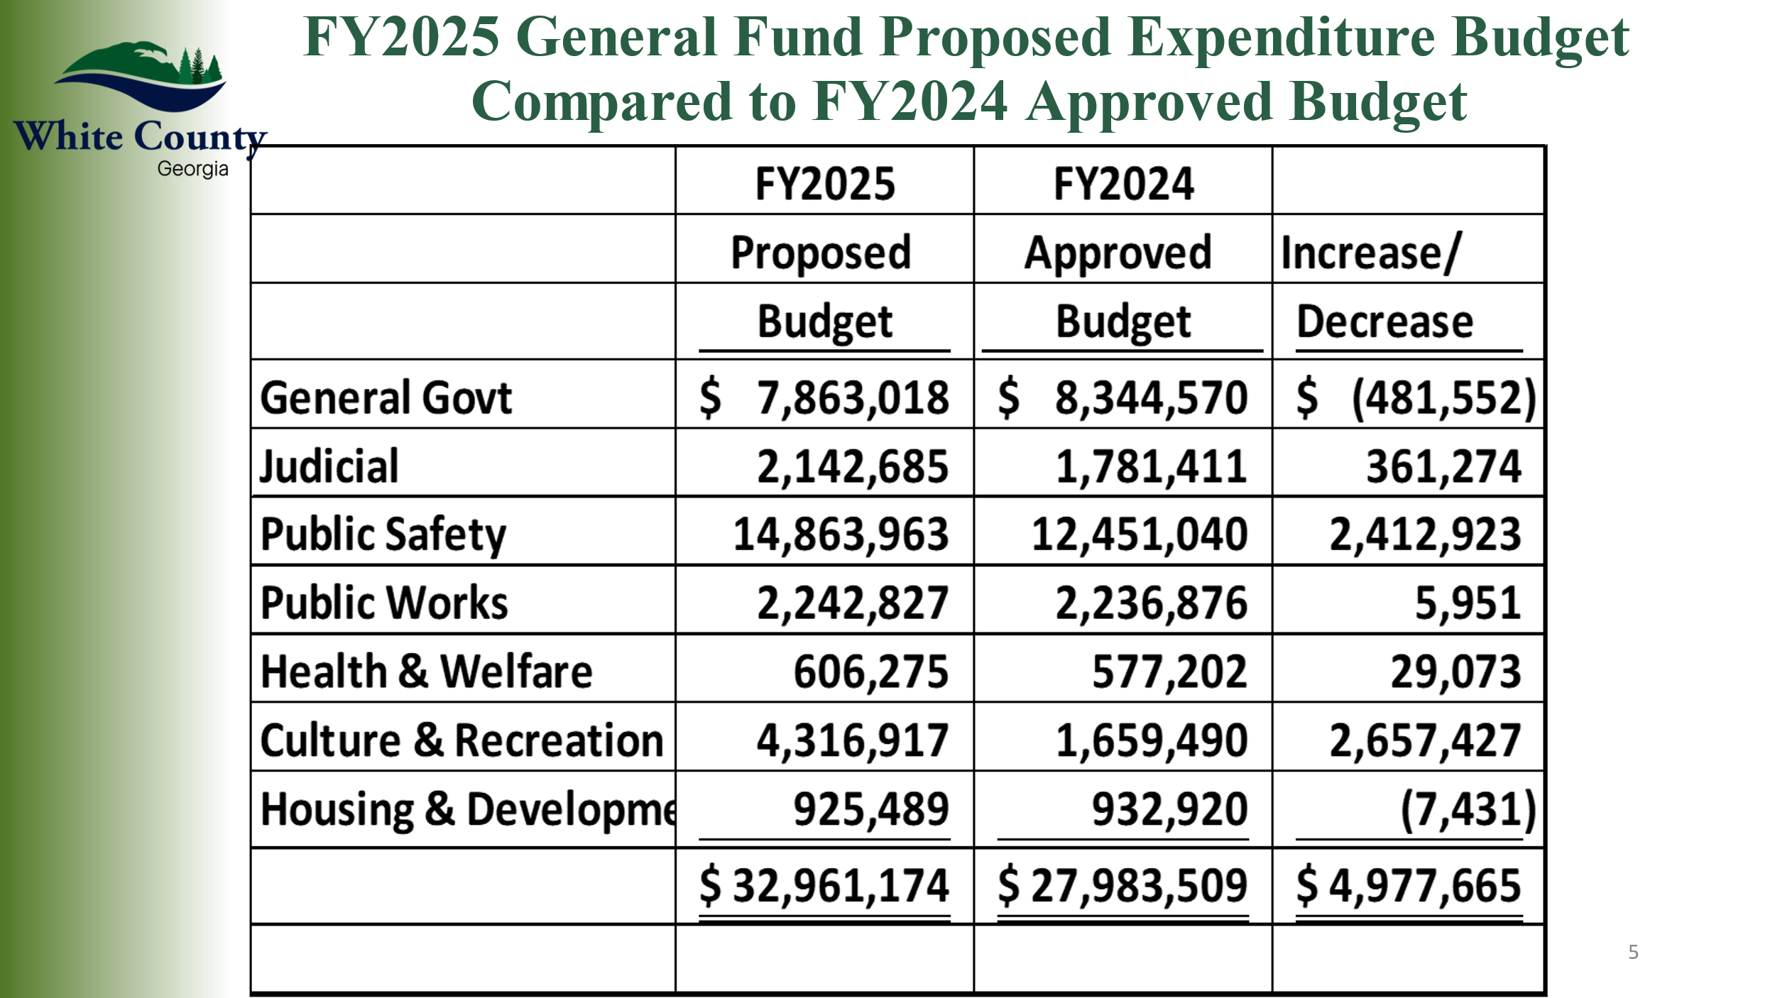

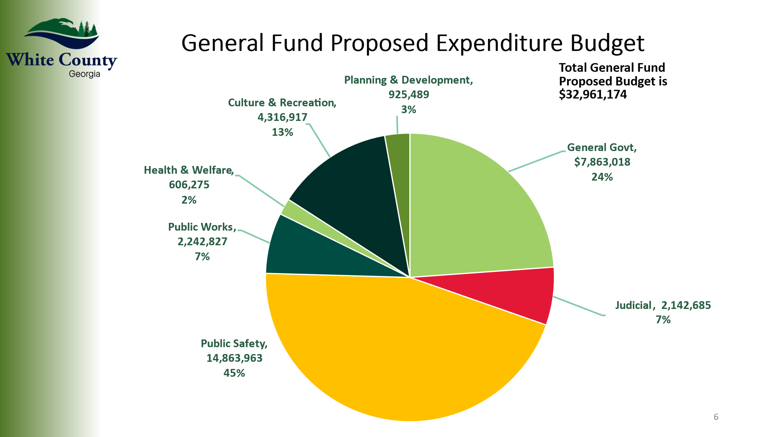

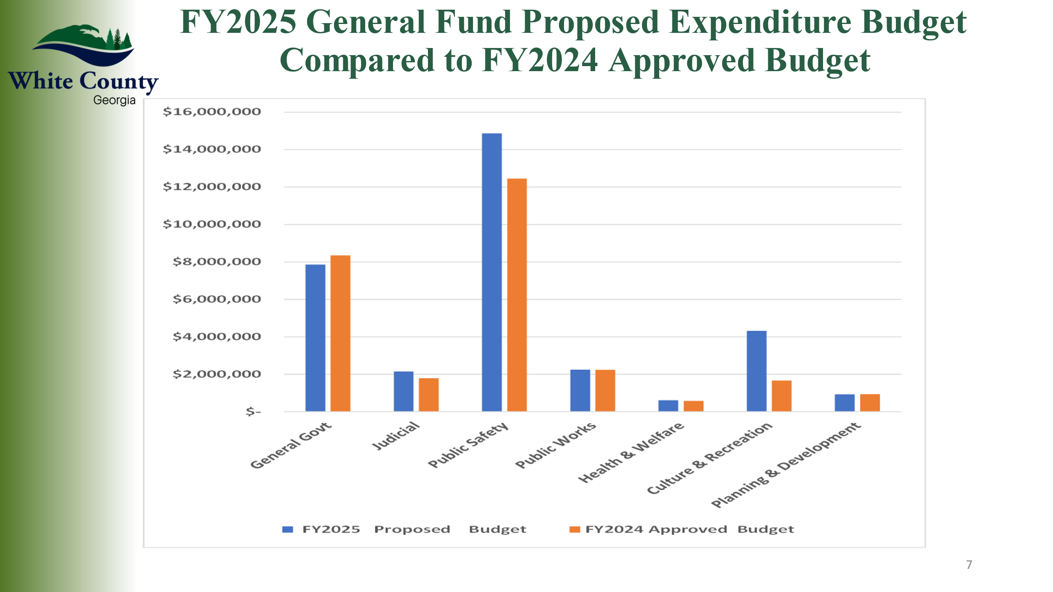

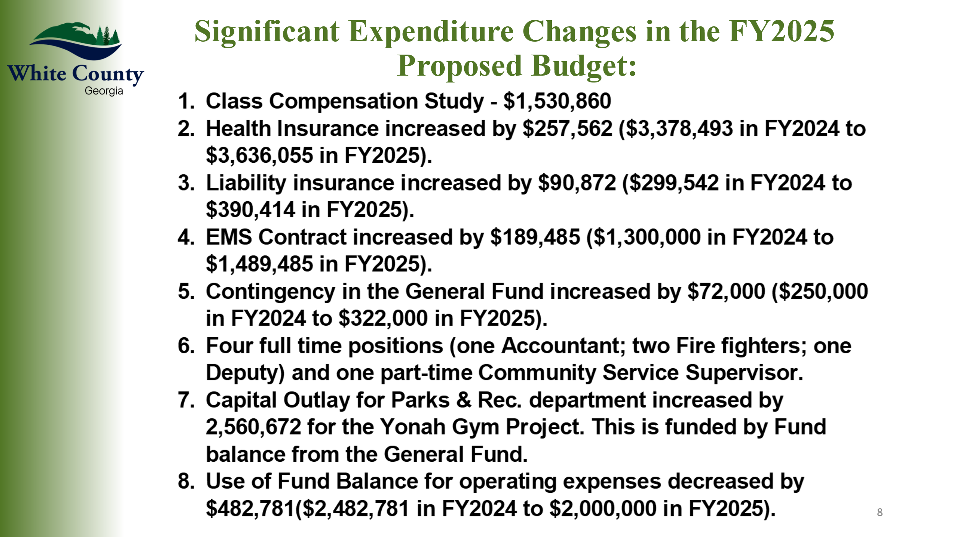

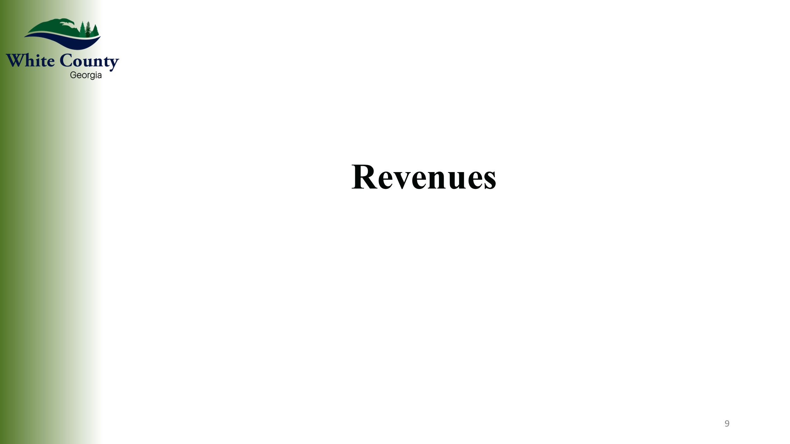

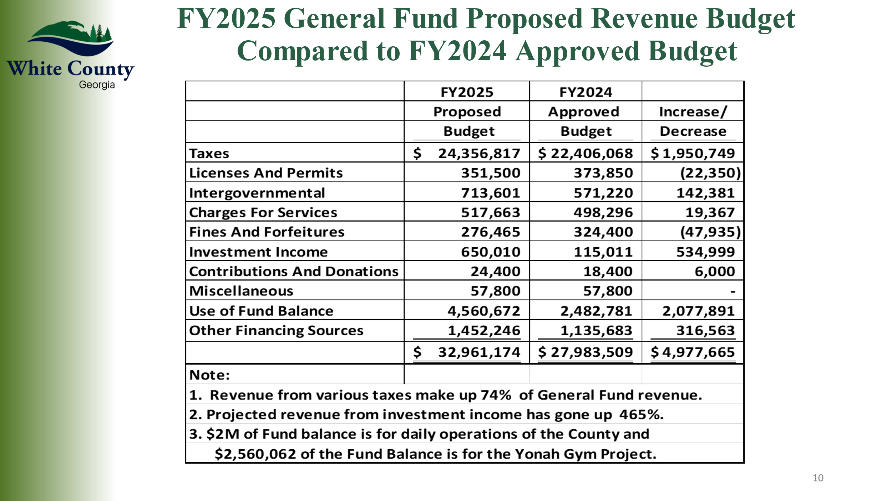

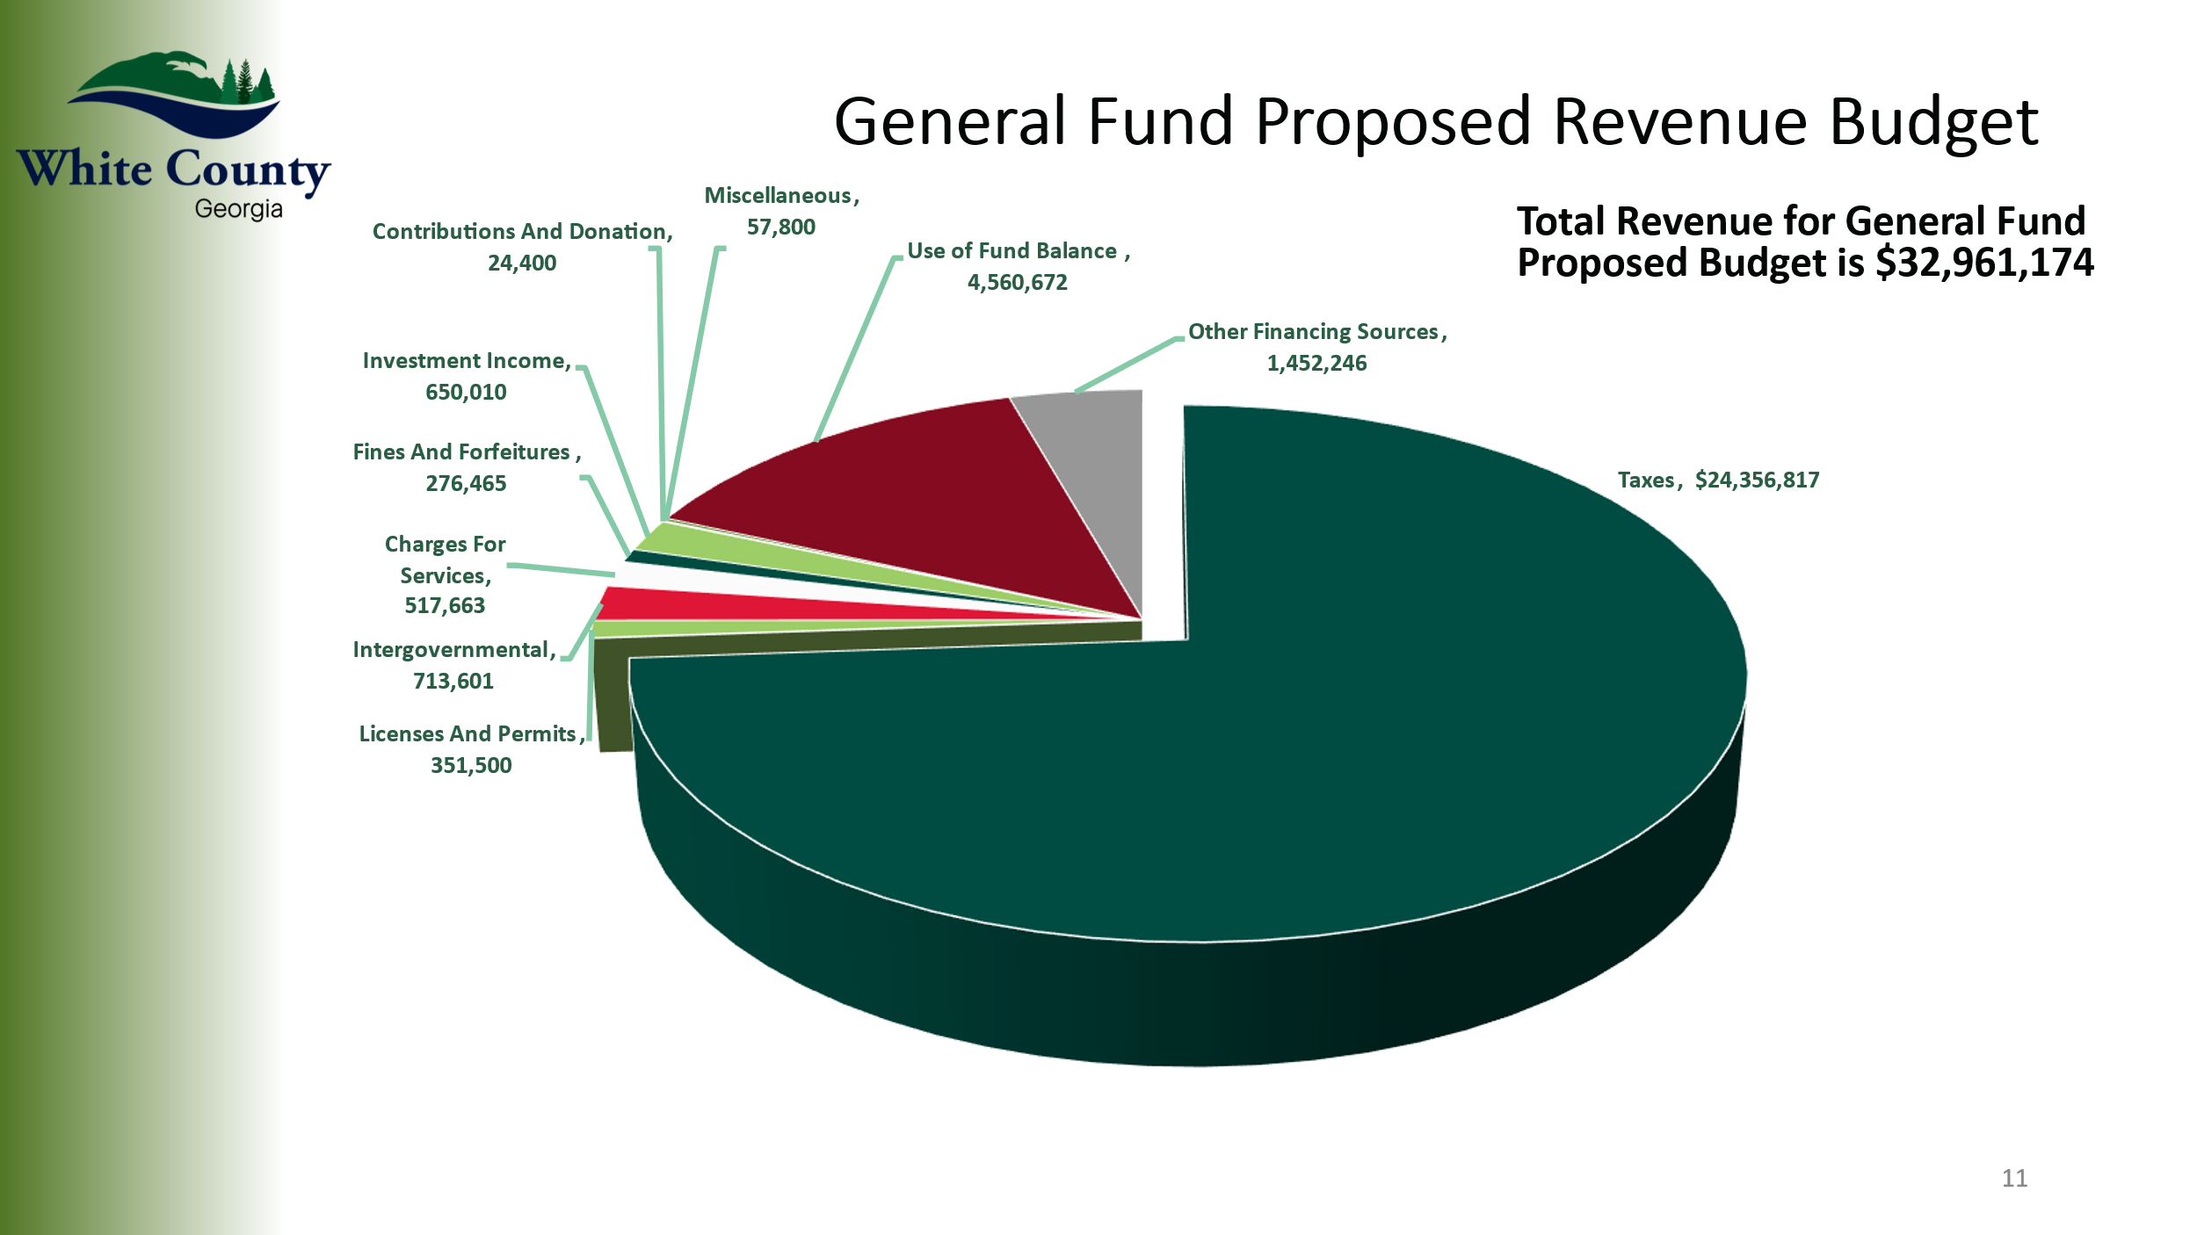

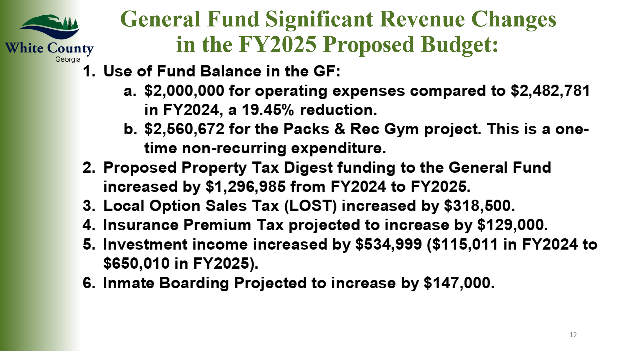

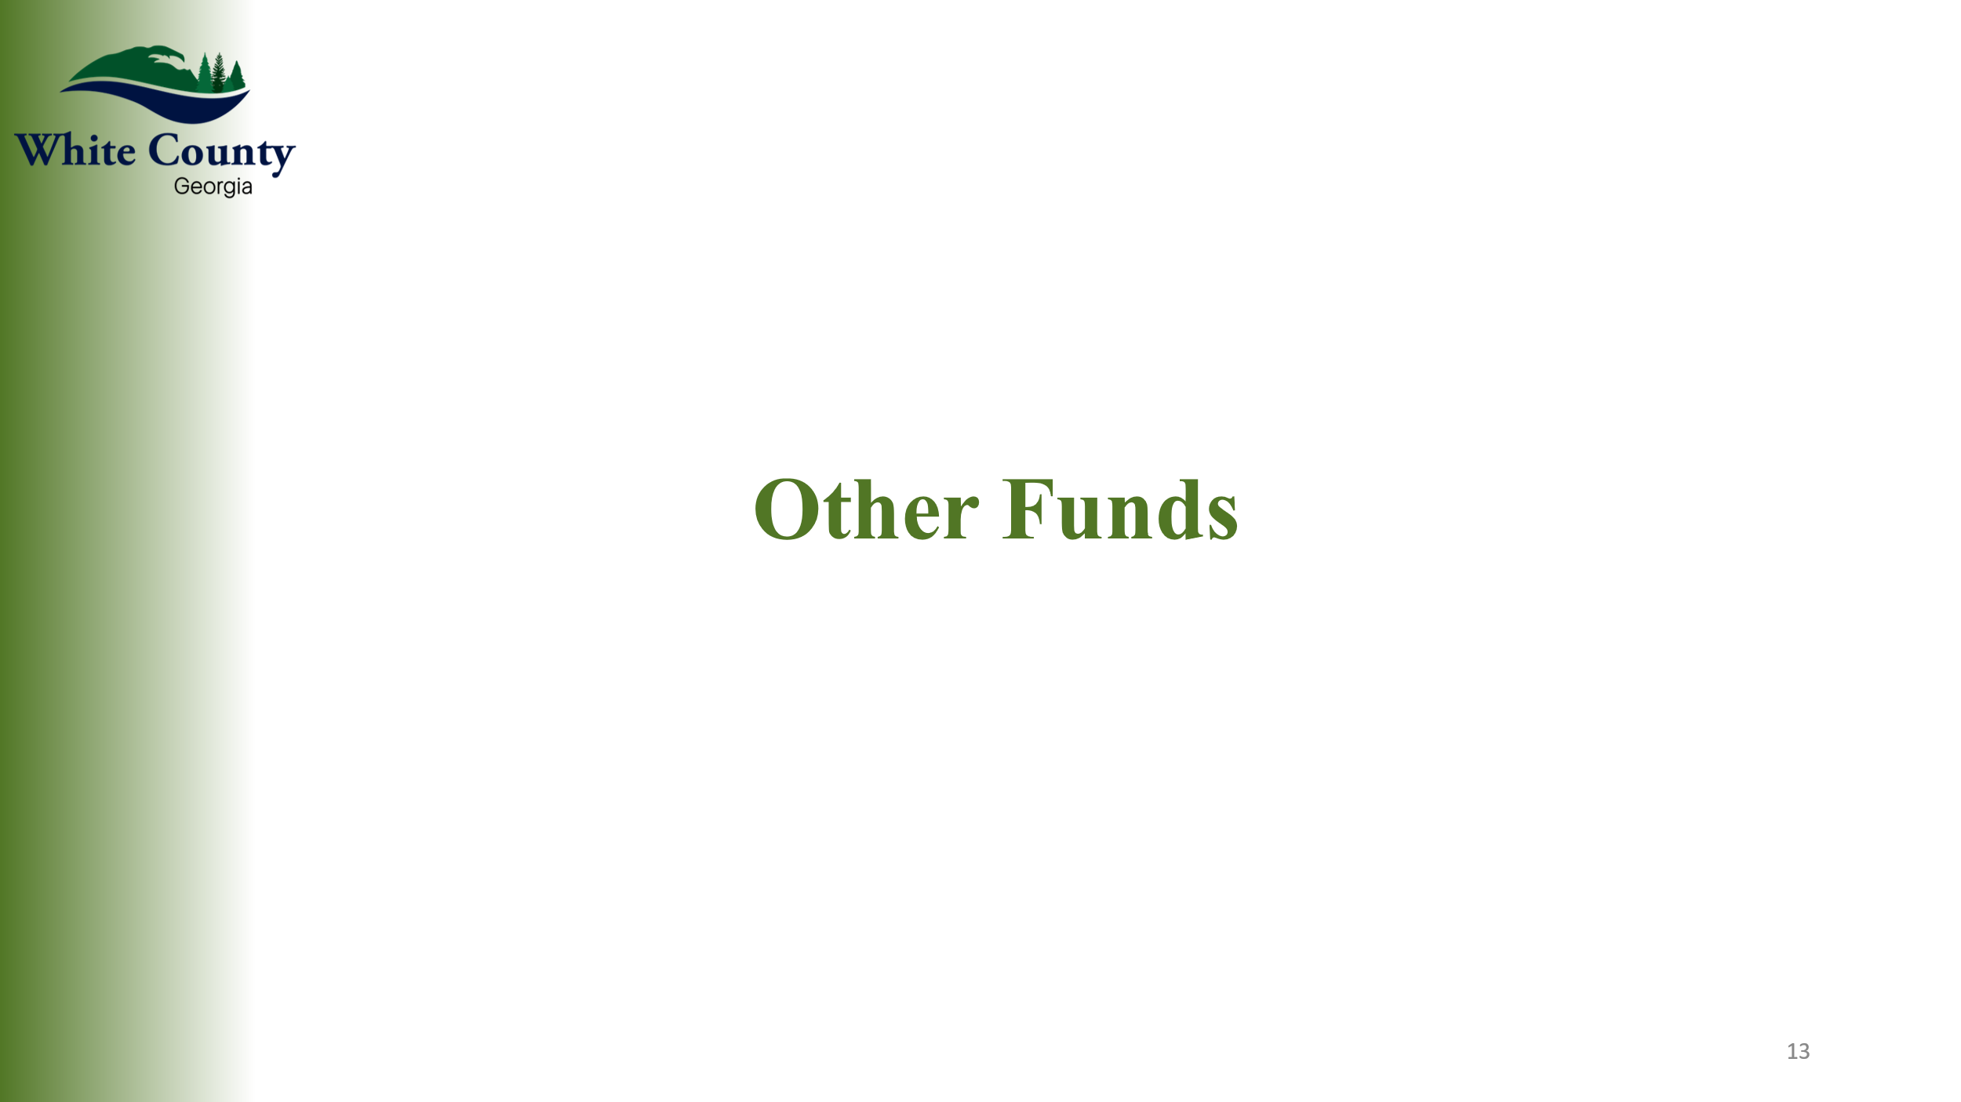

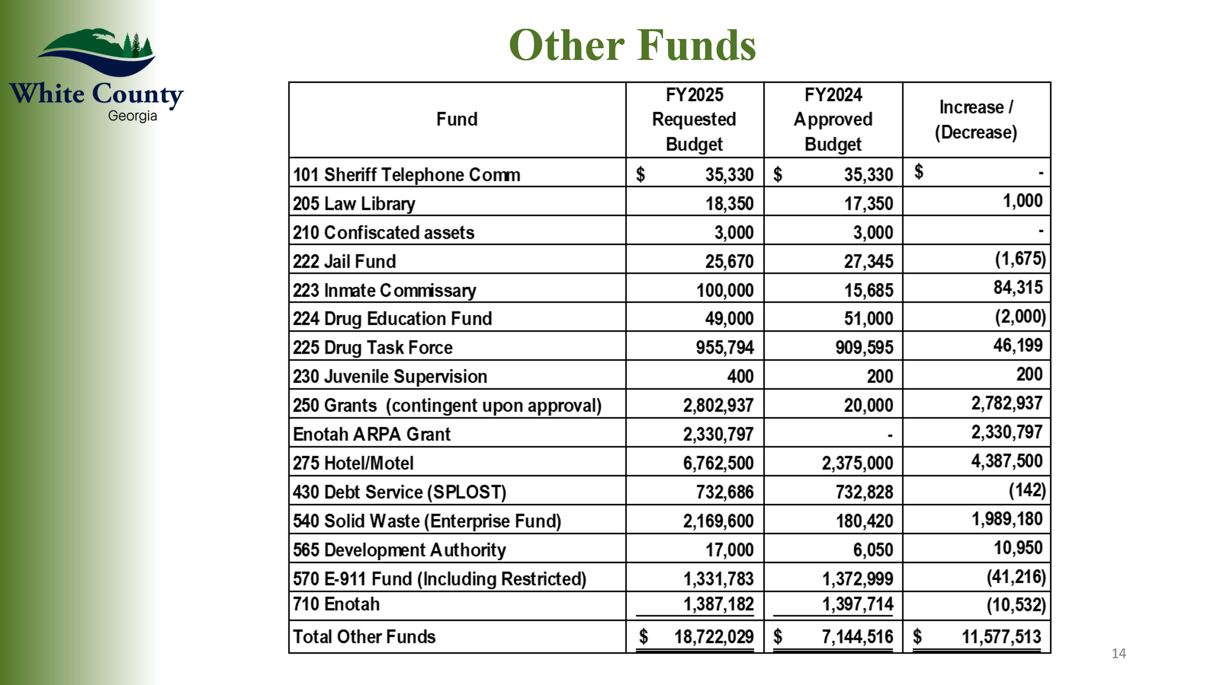

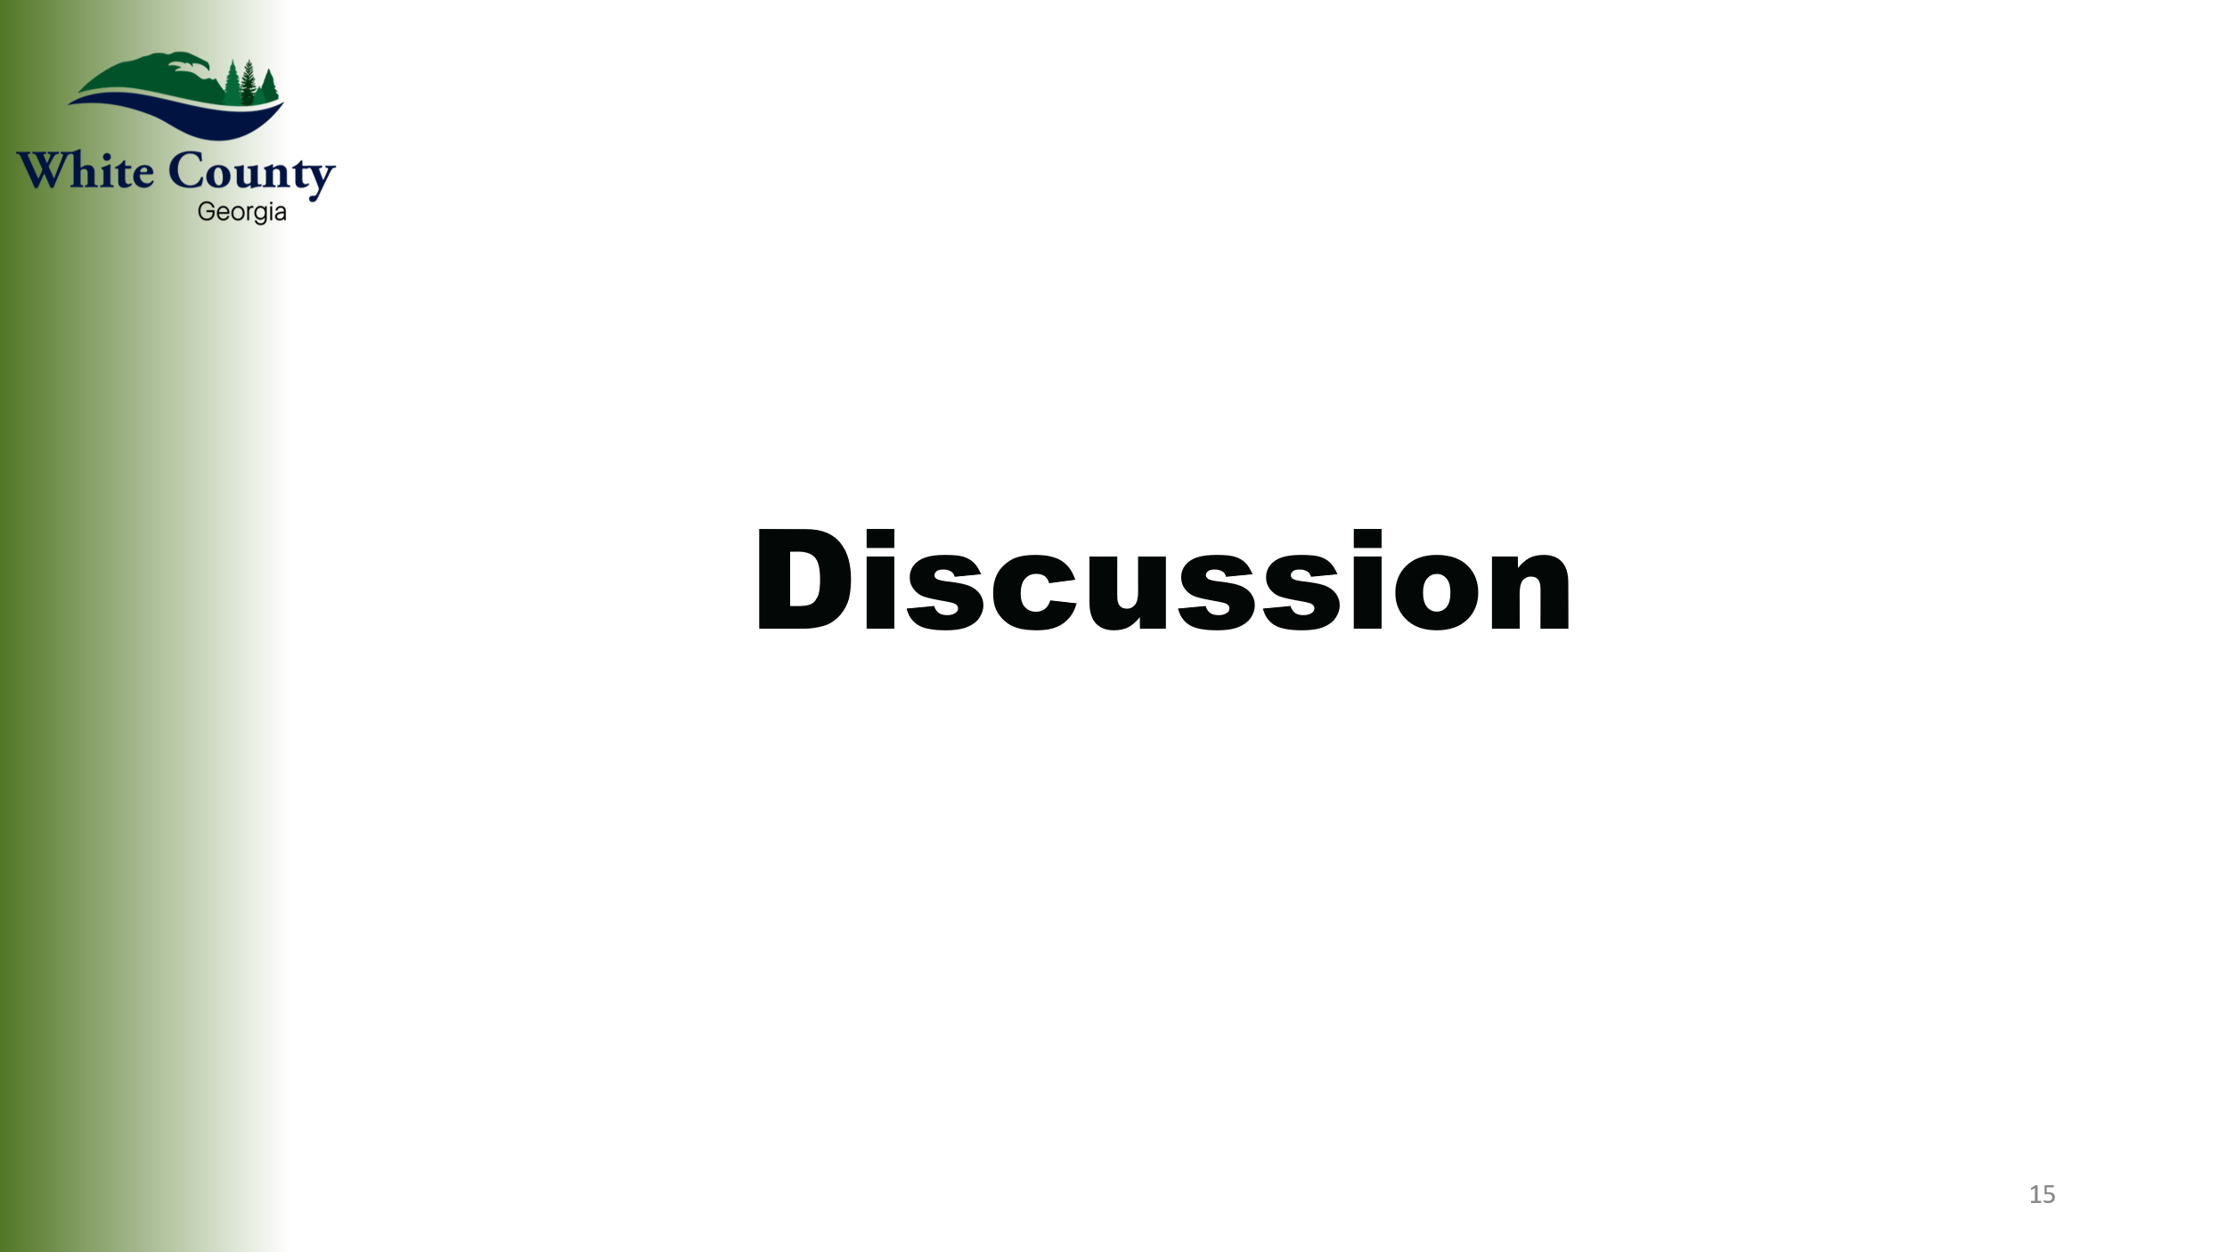

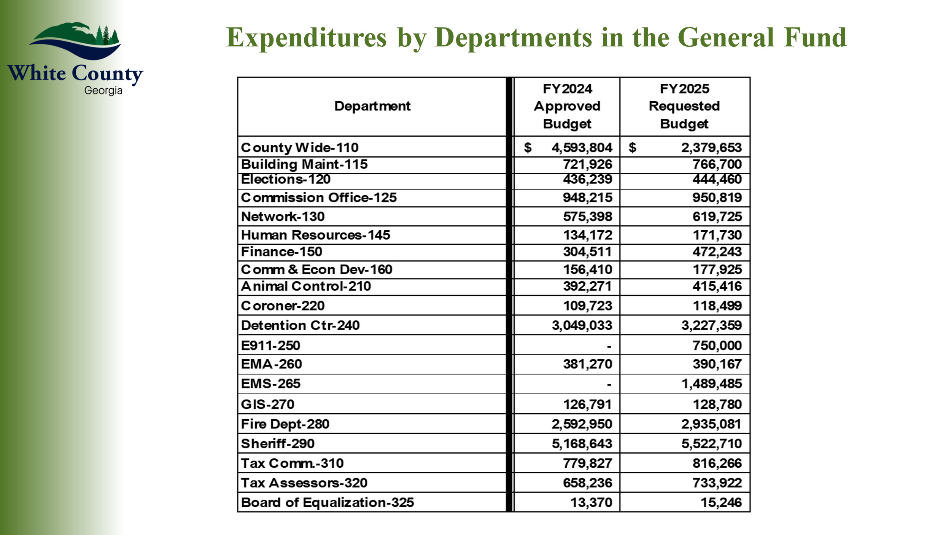

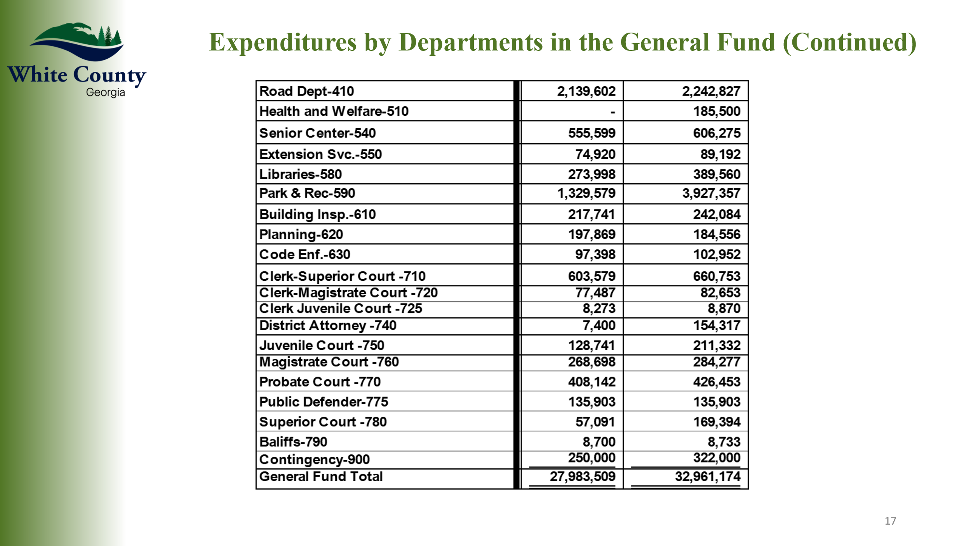

* End of Presentation *

Mr. Pittard highlighted how several expenses which were previously shown in Department 125 (Countywide), had been reclassified to a more appropriate department within the budget. He also noted that there was a one-time $2,560,672.00 expense in the General Fund Budget (590 Parks & Recreation) for the gym construction project. Mr. Pittard also reviewed the Separate Funds, stating that since a significant amount of that fund’s, fund balance ($4,387,500.00) would be used for the gym construction project, this amount is included as both a revenue and expense within the Hotel / Motel Tax Fund – therefore the numbers associated with this fund are much higher than the actual revenues and expenses anticipated. He also reviewed that the Solid Waste Fund had increased significantly due revenue now coming to the County since the County has assumed the operations for the Transfer Station, which were previously contracted to Waste Management. He also advised that the increase in the Inmate Commissary Fund was due to the planned purchase of a body scanner for the jail. In closing, Mr. Pittard expressed his appreciation to Ms. Rose Kisaalita, the Elected Officials, and County Department Heads for their hard work on developing the FY 2025 Budget being presented.

Chairman Turner opened the floor for public comment on the proposed Fiscal Year 2025 Budget. There were no comments, and the floor was closed.

It was stated that the Board would be considering approval of the proposed Fiscal Year 2025 Budget at a Called Meeting on Thursday, June 20th at 9:00 a.m.

Upon a motion made by Commissioner Holcomb, seconded by Commissioner Bryant, there was a unanimous vote to adjourn the meeting.

The minutes of the June 13, 2024 Public Hearing were approved as stated this 24th day of June, 2024.

**WHITE COUNTY BOARD OF COMMISSIONERS**

s/Travis C. Turner  
Travis C. Turner, Chairman

s/Terry D. Goodger

Terry D. Goodger, District 1

s/Lyn Holcomb

Lyn Holcomb, District 2

s/Edwin Nix

Edwin Nix, District 3

s/Craig Bryant

Craig Bryant, District 4  
  
s/Shanda Murphy  
Shanda Murphy, County Clerk