WHITE COUNTY BOARD OF COMMISSIONERS
MINUTES OF THE WORK SESSION & REGULAR MEETING HELD
MONDAY, JUNE 3, 2024 AT 4:30 P.M.
The White County Board of Commissioners held a Work Session & Called Meeting on Monday, June 3, 2024 at 4:30 p.m. in the Board Room at the Administration Building. Present for the meeting were: Chairman Travis Turner, Commissioner Terry Goodger, Commissioner Lyn Holcomb, Commissioner Edwin Nix, Commissioner Craig Bryant, County Manager Billy Pittard, Interim Finance Director Rose Kisaalita, and County Clerk Shanda Murphy.
Chairman Turner called the meeting to order.
Following the Pledge of Allegiance, Rev. Burnetta Armour with the Cleveland Presbyterian Church & White County Ministerial Alliance, provided the invocation.
Upon a motion made by Commissioner Bryant, seconded by Commissioner Holcomb there was a unanimous vote to adopt the minutes of the May 6, 2024 Regular Meeting (including Executive Session) and of the May 20, 2024 Called Meeting.
Mr. John Sell, Director of Community & Economic Development, presented the appeal filed by Mr. John Mitchell requesting the addition of Yonah Mountain Heights Subdivision Cleveland, Georgia to the White County Short-Term Rental Subdivision Map. He explained that Mr. Mitchell was requesting a total of 33 parcels to be added to the map as a subdivision, which would result in no additional short-term rentals being allowed (under current regulation) in Yonah Mountain Heights. He stated the subdivision had not been platted and the subdivision map was based on platted subdivisions of four (4) or more lots in common development. Mr. Mitchell had researched and provided deeds for all 33 parcels which referenced the properties being part of the Yonah Mountain Heights Subdivision and being subject to restrictive covenants. Mr. Sell noted that 32% of the properties in this subdivision are already approved as short-term rentals and many of the property owners had said that they do not want any more short-term rentals in the area. He also advised that there is a road owner’s association, but no valid homeowner’s association and for that reason at least one (1) property owner (Morales) has expressed that he is against the appeal. Mr. John Mitchell spoke on behalf of his application of appeal and provided a history of the development. He confirmed that in 1998 there was a valid homeowner’s association. Commissioner Bryant confirmed that the properties in appeal are accessed by a private road which is gated. Mr. Mitchell stated that past the gate, there are properties in four (4) different developments – Yonah Peak, Eagles Pass, Cameron Acres, and Yonah Mountain Heights – and his request only pertained to the properties in Yonah Mountain Heights.
Upon a motion made by Commissioner Goodger, seconded by Commissioner Bryant there was a unanimous vote to approve the appeal filed by Mr. John Mitchell requesting the addition of Yonah Mountain Heights Subdivision Cleveland, Georgia to the White County Short-Term Rental Subdivision Map.
Mr. Sell presented a proposal for amending numerous articles of the White County Code of Ordinances to require the digital submission of site plans, plats, plans, and drawings and amending the Code to update the procedure for recording plats and adding the definition of a subdivision to Appendix A to match the definition in Article 16.
Upon a motion made by Commissioner Holcomb, seconded by Commissioner Goodger there was a unanimous vote to adopt County Resolution 2024-09 amending numerous articles of the White County Code of Ordinances to require the digital submission of site plans, plats, plans, and drawings and amending the Code to update the procedure for recording plats and adding the definition of a subdivision to Appendix A to match the definition in Article 16 as follows:
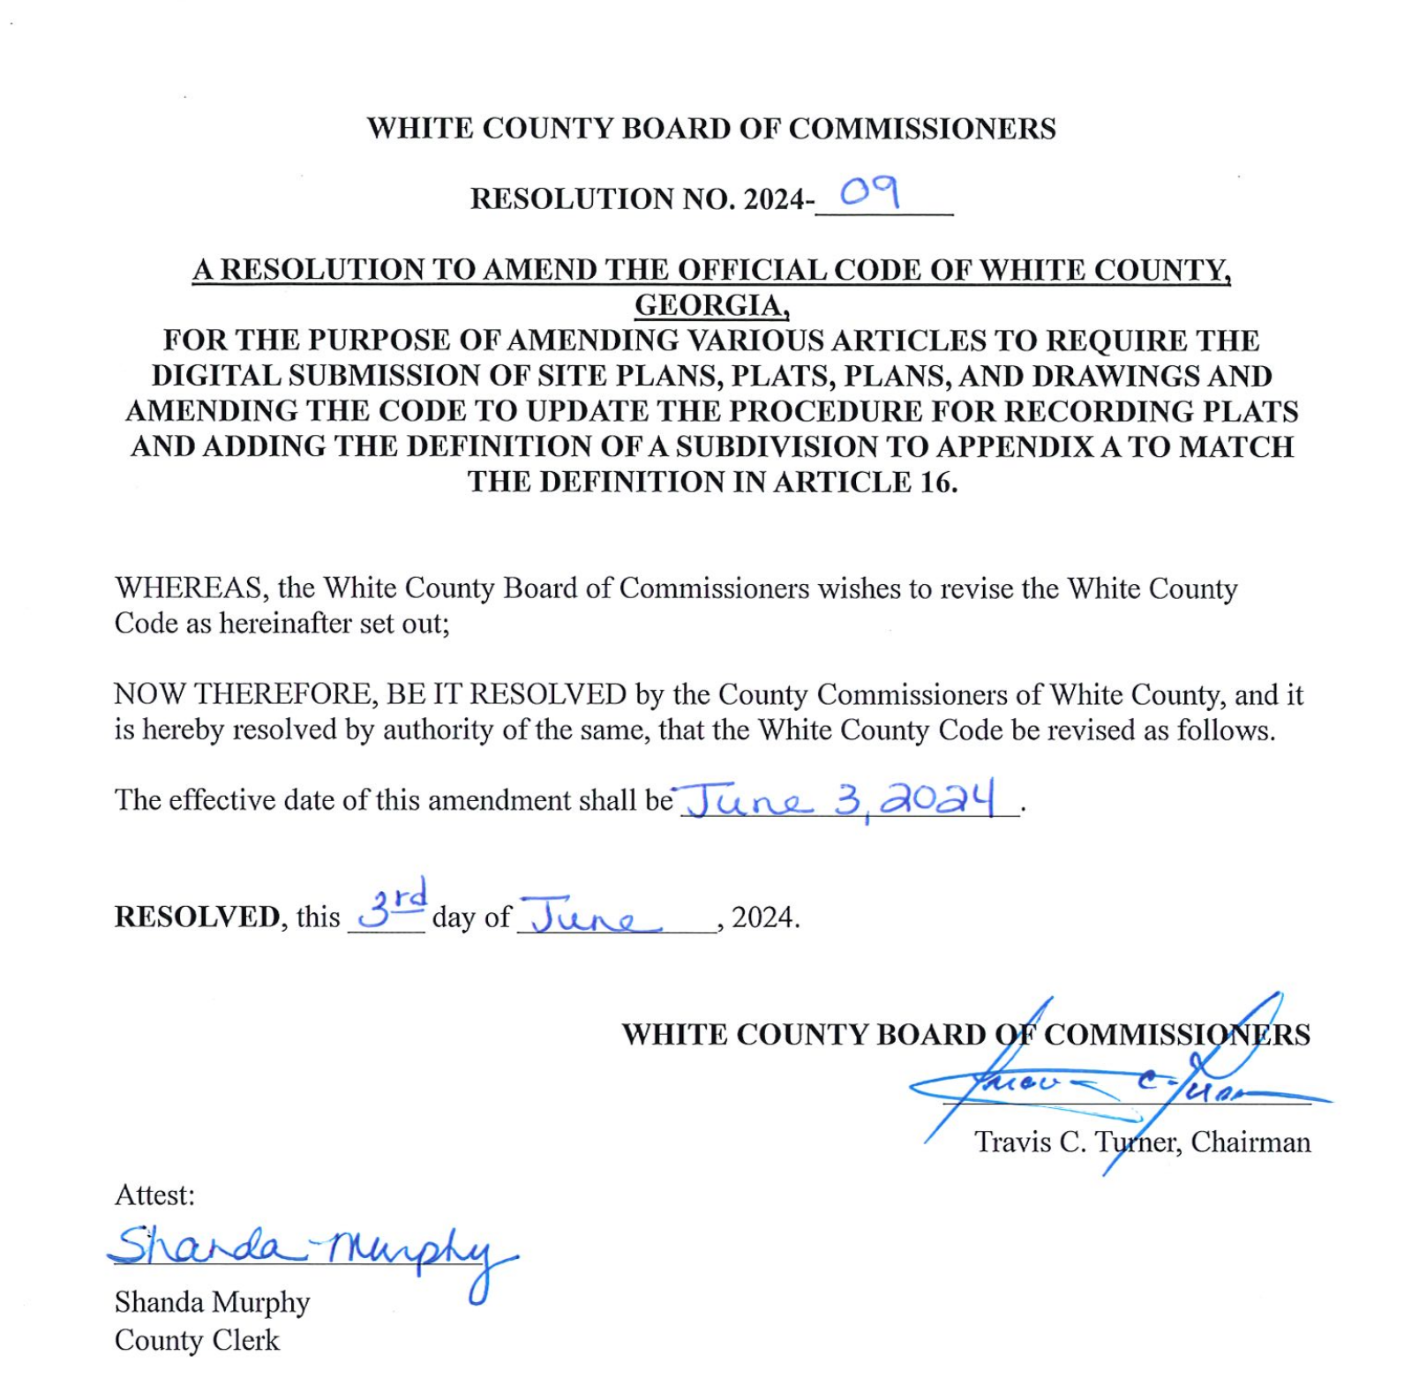 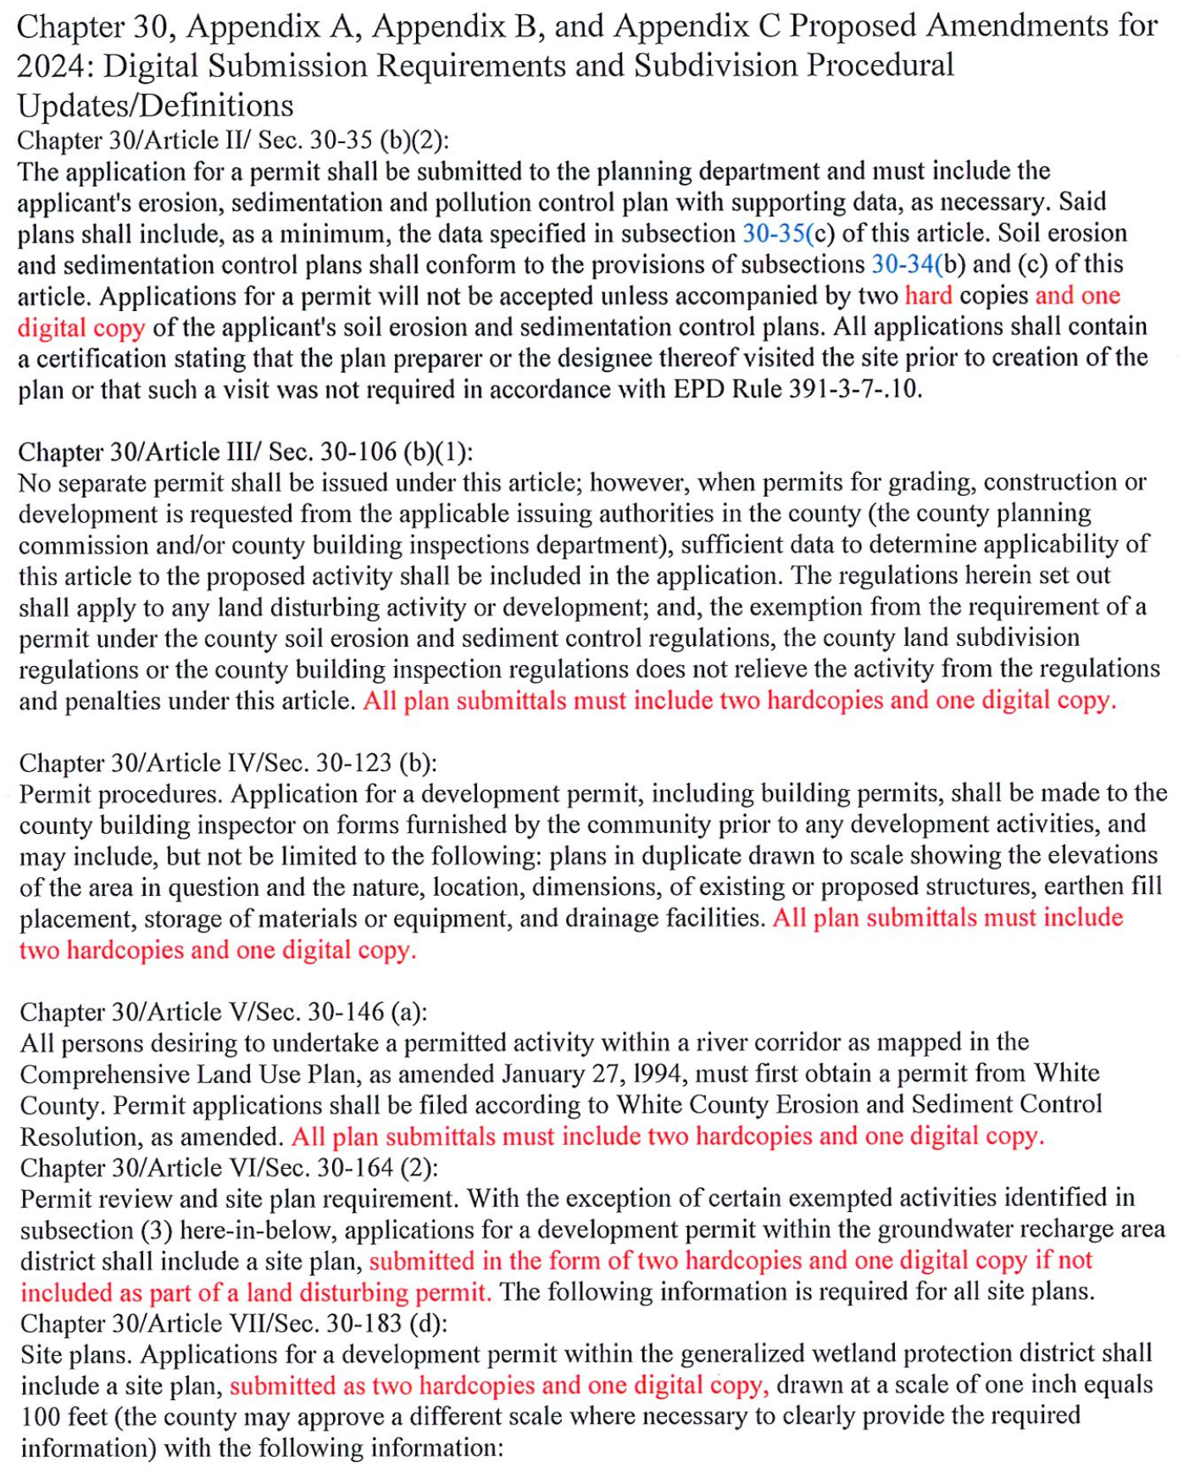
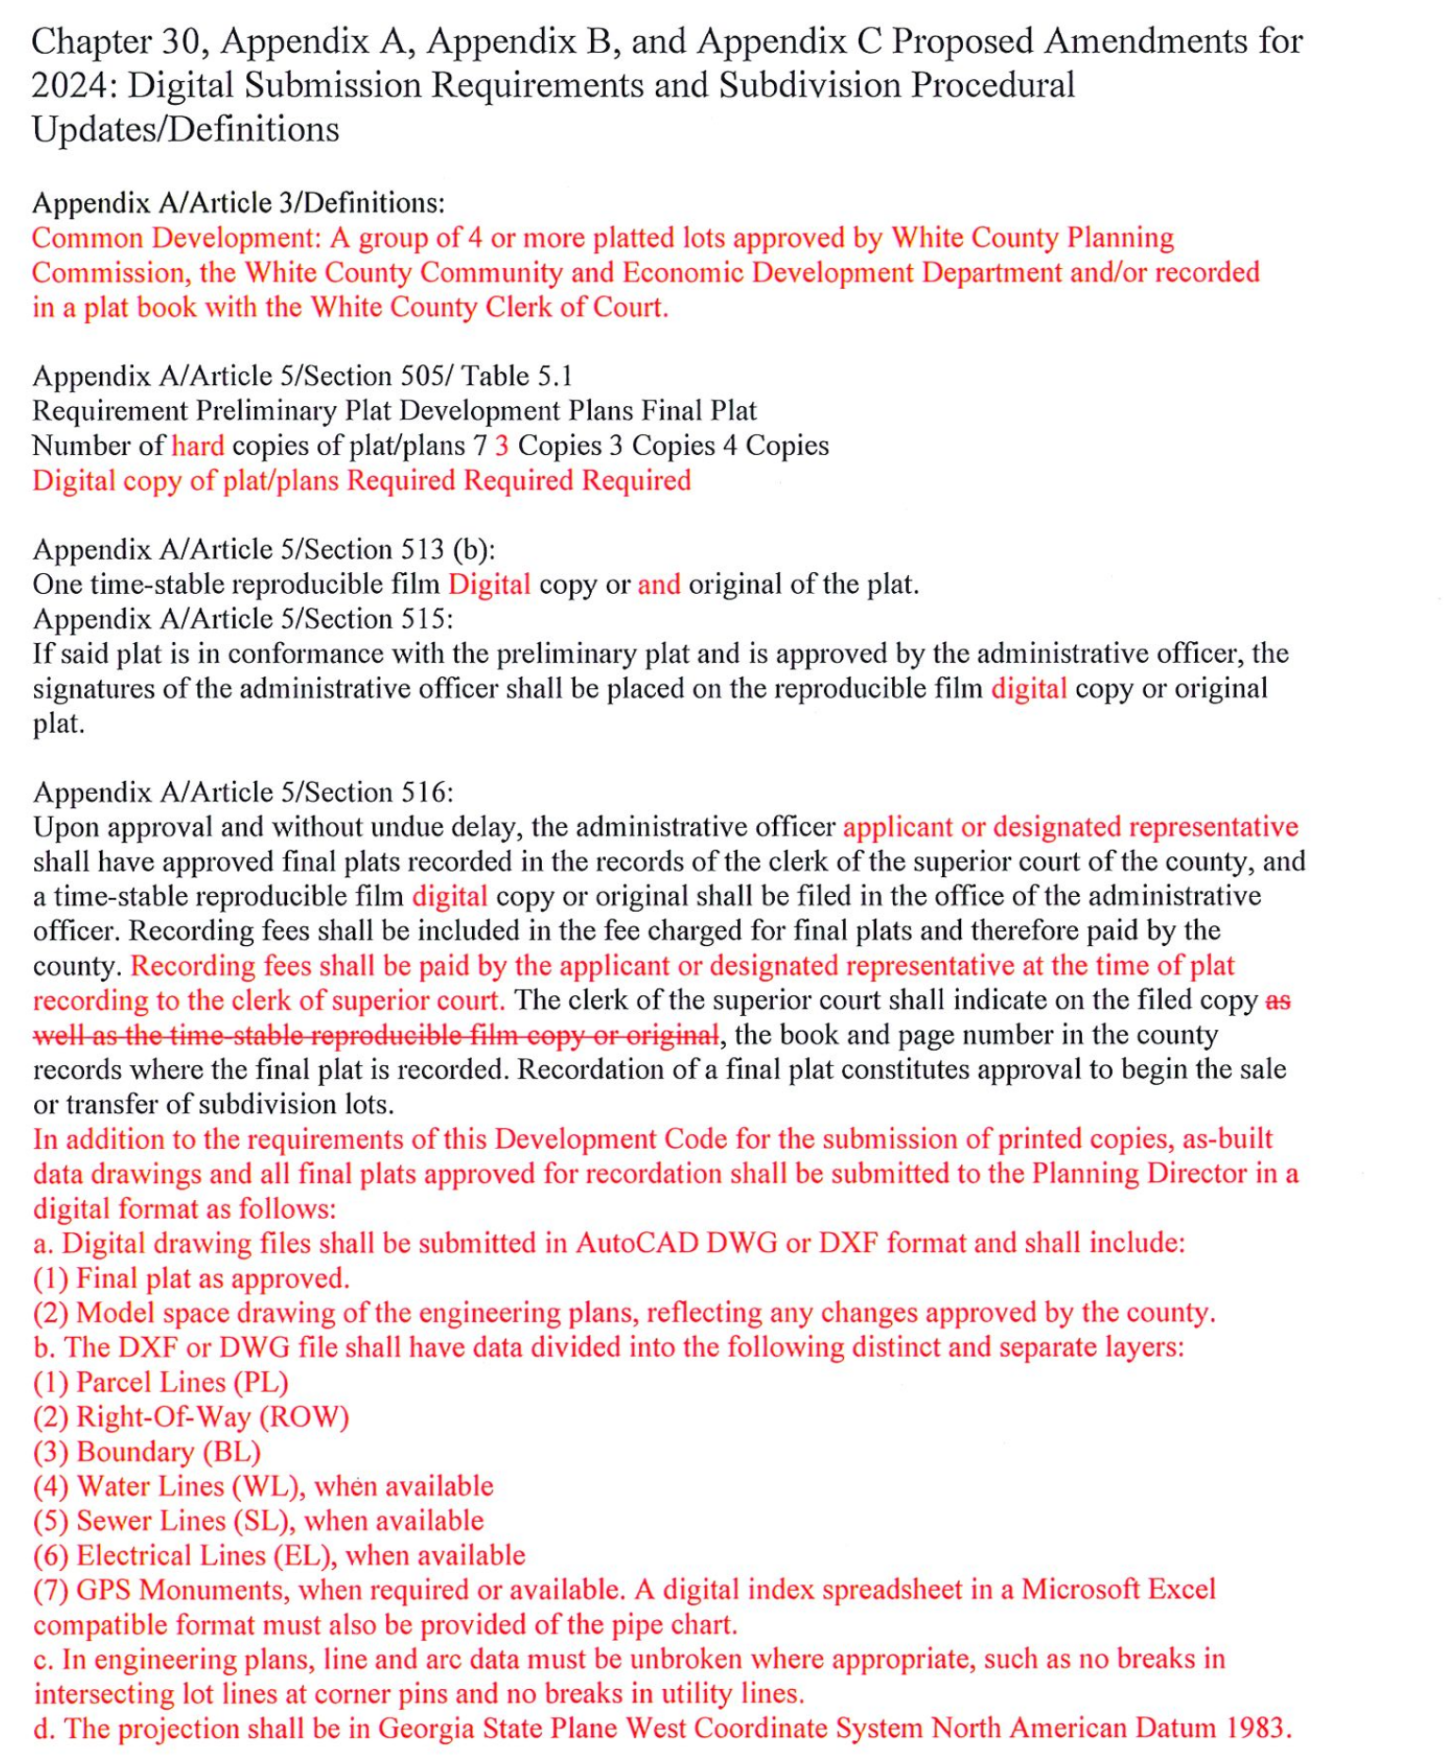

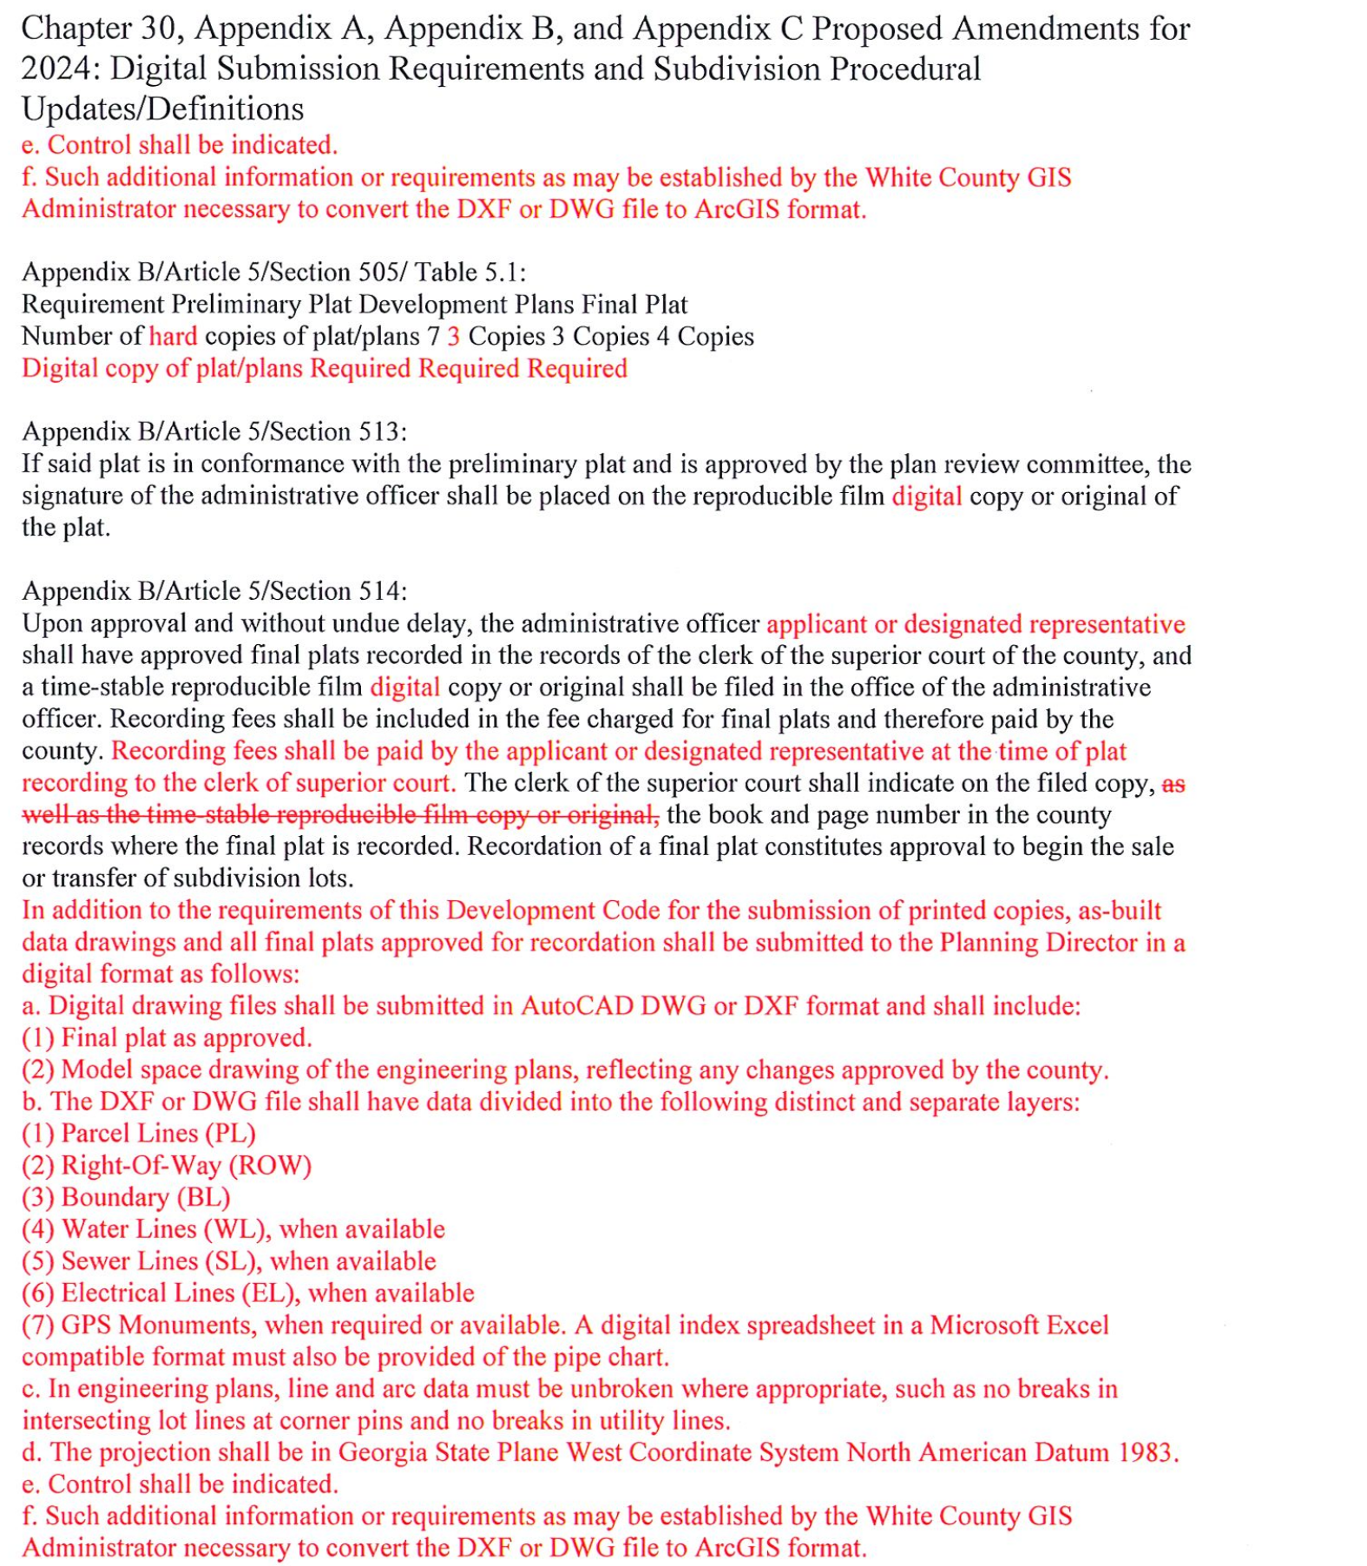
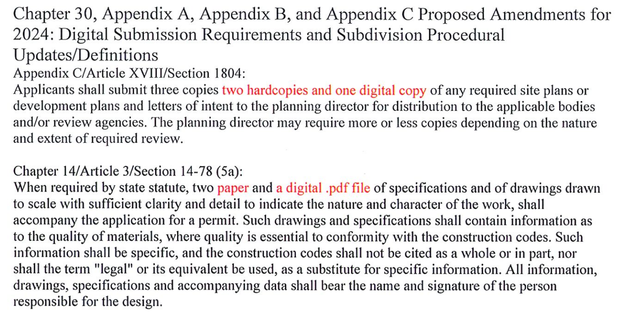
-End of County Resolution No. 2024-09-
Mr. Derick Canupp, Director of Public Works, presented a proposal to purchase a 35-cubic yard compactor for plastics recycling at the Convenience Center for the total cost of $30,690.00. He stated that recently a cardboard compactor had been purchased and installed and it had made a very positive impact on the efficiency with the cardboard recycling, and they would like to do the same with the plastics recycling bin, which is currently collected in a closed top roll off container and customer currently have to dispose small amounts through an opening in the front of the container. He advised that the new set-up would allow customers to dump containers of plastics in at one time and would greatly reduce the number of times the plastics had to be hauled each week due to the compaction. He stated that the return on investment would be seen in 24 months conservatively (15 to 16 months realistically).
Upon a motion made by Commissioner Nix, seconded by Commissioner Goodger there was a unanimous vote to approve the purchase of a 35-cubic yard compactor for plastics recycling at the Convenience Center through Fleet Genius in the amount of $30,390.00 (including installation) to be funded by the Solid Waste Fund.
Mr. Canupp presented a request to purchase a replacement Ford F-150 for the Road Department. He stated this would replace a 1997 F-150 that had 275,000 miles and had been in the repair shop 14 times in the past two (2) years. He advised that sealed bids had been accepted for the truck and the lowest bidder was Jacky Jones Ford of Hayesville, NC at $44,002.52. He said the lead time on delivery of the vehicle would be three (3) months.
Upon a motion made by Commissioner Bryant, seconded by Commissioner Holcomb there was a unanimous vote to approve the purchase of a 2024 Ford F150 from Jacky Jones Ford Hayesville, NC in the amount of $44,002.52 – to be funded through SPLOST.
Ms. Kimberly McEntire, Director of Parks & Recreation, presented an annual contract for chemical application for all the Parks & Recreation athletic fields. She explained that the contract was bid out, only two (2) bids were received, and the current contractor (Tru Green) was the low bidder. She stated that there had been some previous issues with Tru Green, however their service had improved, and she is comfortable renewing the contract with them.
Upon a motion made by Commissioner Holcomb, seconded by Commissioner Nix there was a unanimous vote to award the annual contract for chemical application for all the Parks & Recreation athletic fields to Tru Green in the amount of $13,200.00 – to be paid from the department’s operational budget.
Commissioner Nix stated that a soil sample needs to be taken on the bare spots along the side of the bridge & road leading into Yonah Preserve as there needs to be grass growing there by now. Various solutions were discussed, and Ms. McEntire said that she would have a soil sample done and apply topsoil and fertilizer.
Ms. Murphy presented the 2024-2025 ACCG- IRMA (Association County Commissioners of Georgia-Interlocal Risk Management Agency) Liability Insurance Renewal. She stated that the increase was $9,720.00 (2.55%) and the annual premium would be $390,414.00 – which had been included in the proposed FY 2025 budget. She said this premium increase was following the 2023-2024 increase of $81,152.00 (27.09%) and the increase of the county per occurrence deductible from $2,500.00 to $10,000.00 – which had more to do with circumstances in the insurance industry, the insured pool, and the economy than with White County’s experience. The coverage insures - property, vehicles, law enforcement liability, public officials’ liability, general liability, and cyber security.
Upon a motion made by Commissioner Nix, seconded by Commissioner Goodger there was a unanimous vote to approve the 2024-2025 ACCG-IRMA (Association County Commissioners of Georgia-Interlocal Risk Management Agency) Liability Insurance Renewal.
Ms. Murphy presented the mid-year board appointments.
Upon a motion made by Commissioner Holcomb, seconded by Commissioner Goodger there was a unanimous vote (4-0) to make the following board appointments – with Commissioner Nix abstaining due to his employment with the White County Water Authority:
• Chamber of Commerce Board of Directors: Reappointment of Mr. Jason Hogan for a two (2) year term
expiring June 30, 2026.
• Department of Family & Children’s Services (DFACS) Board: Reappointment of Mr. Michael Fisher for a five
(5) year term expiring June 30, 2029.
•Development Authority: Reappointment of Ms. Virgina Roberts and Mr. Michael Meuse for a six (6) year term
expiring June 30, 2030.
• Georgia Mountains Regional Commission Council (GMRC) Private Sector Representative: Appointment of
Ms. Lauren Williams for a one (1) year term expiring June 30, 2025.
• White County Water Authority: Reappointment of Mr. David Sills representing the Upper Chattahoochee
River Soil and Water Conservation District and Mr. Mike Mays representing the general public – both for a
two (2) year term expiring June 30, 2026.
Following these appointments, the mid-year board appointments remaining to be filled were as follows:
• Avita Community Partners: One (1) appointee for a two (2) year term expiring June 30, 2026, and
•Department of Family & Children’s Services (DFACS) Board: One (1) appointee for a five (5) year
term expiring June 30, 2029.
Ms. Murphy was instructed to re-advertise these vacancies.
Ms. Rose Kisaalita presented the preliminary Enotah Judicial Circuit Budget for the 2024-2025 Fiscal Year. She stated that representatives of the four (4) circuit counties met on May 23, 2024 and each segment of the circuit presented their proposed budget. She provided a summary of the information presented by the Superior Court, Juvenile Court, District Attorney’s Office, and Public Defender’s Office. In summary, she said the portion of the circuit administered by White County (Superior Court, Juvenile Court, District Attorney’s Office) would be utilizing $68,891.00 of fund balance and the Public Defender would be utilizing $68,891.00 of fund balance. The Superior Court, Juvenile Court, District Attorney’s Office combined budgets decreased $10,532.00 (0.75%) to $1,387,182.00 and the Public Defender’s budget increased $25,99.00 (5.11%) to $535,026.00. Ms. Kisaalita advised that White County’s contribution for the Superior Court, Juvenile Court, and District Attorney’s Office would remain the same from FY 2024 to FY 2025 at $326,481.00 and White County’s contribution to the Public Defender’s budget would increase from $135,903.00 to $136,084.00 ($181.00).
Upon a motion made by Commissioner Holcomb, seconded by Commissioner Nix, there was a unanimous vote to approve the preliminary Enotah Judicial Circuit Budget for the 2024-2025 Fiscal Year. Chairman Turner asked that Ms. Kisaalita advise the other circuit counties that White County had approved this measure.
Mr. Pittard advised the Board that he had asked the county departments to review all fees charged by their various departments and to recommend any necessary changes. He said that he would make this an annual practice in conjunction with the annual budget. He advised that the proposed resolution contained all fees, however the departments with recommended changes are Planning & Development, Public Works, Senior Center, and Business Licensing. The departments with proposed changes presented those revisions and the Board discussed all the various fees.
Upon a motion made by Commissioner Holcomb, seconded by Commissioner Goodger there was a unanimous vote to adopt County Resolution 2024-10, Establishing the 2024-2025 County Departments Fee Schedule:
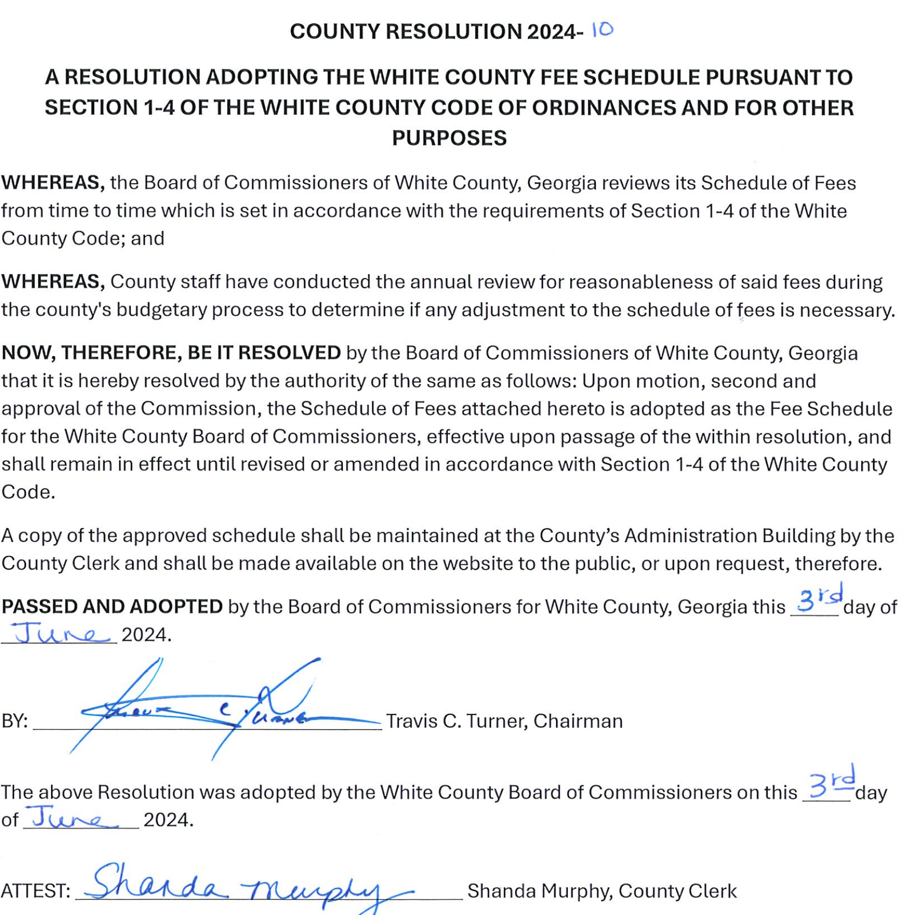
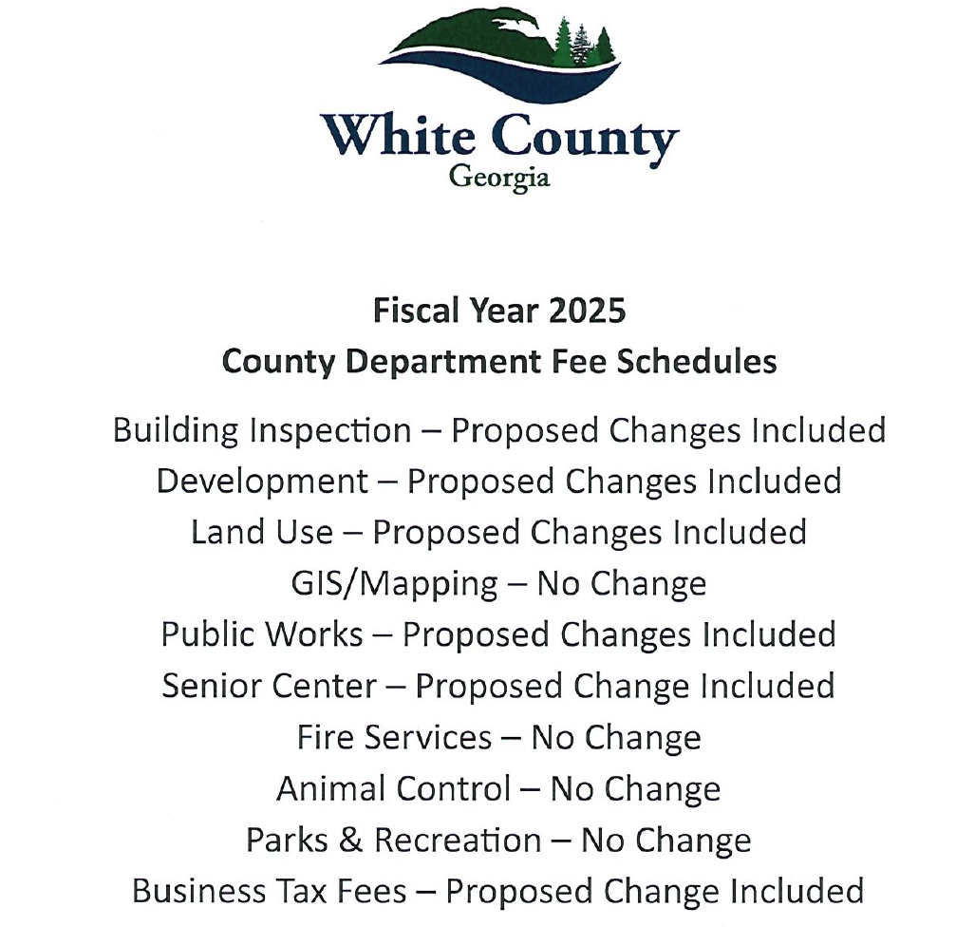
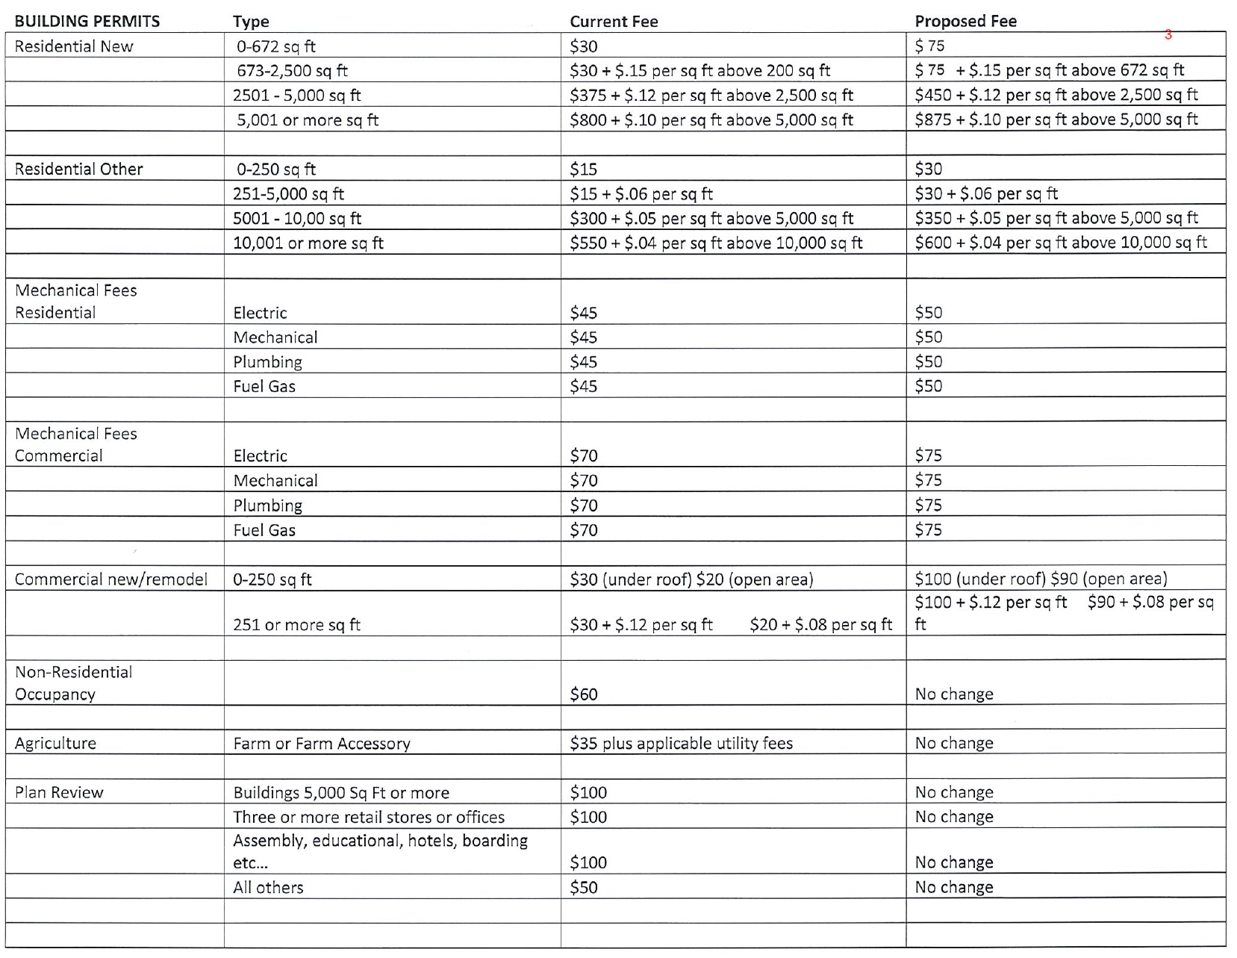
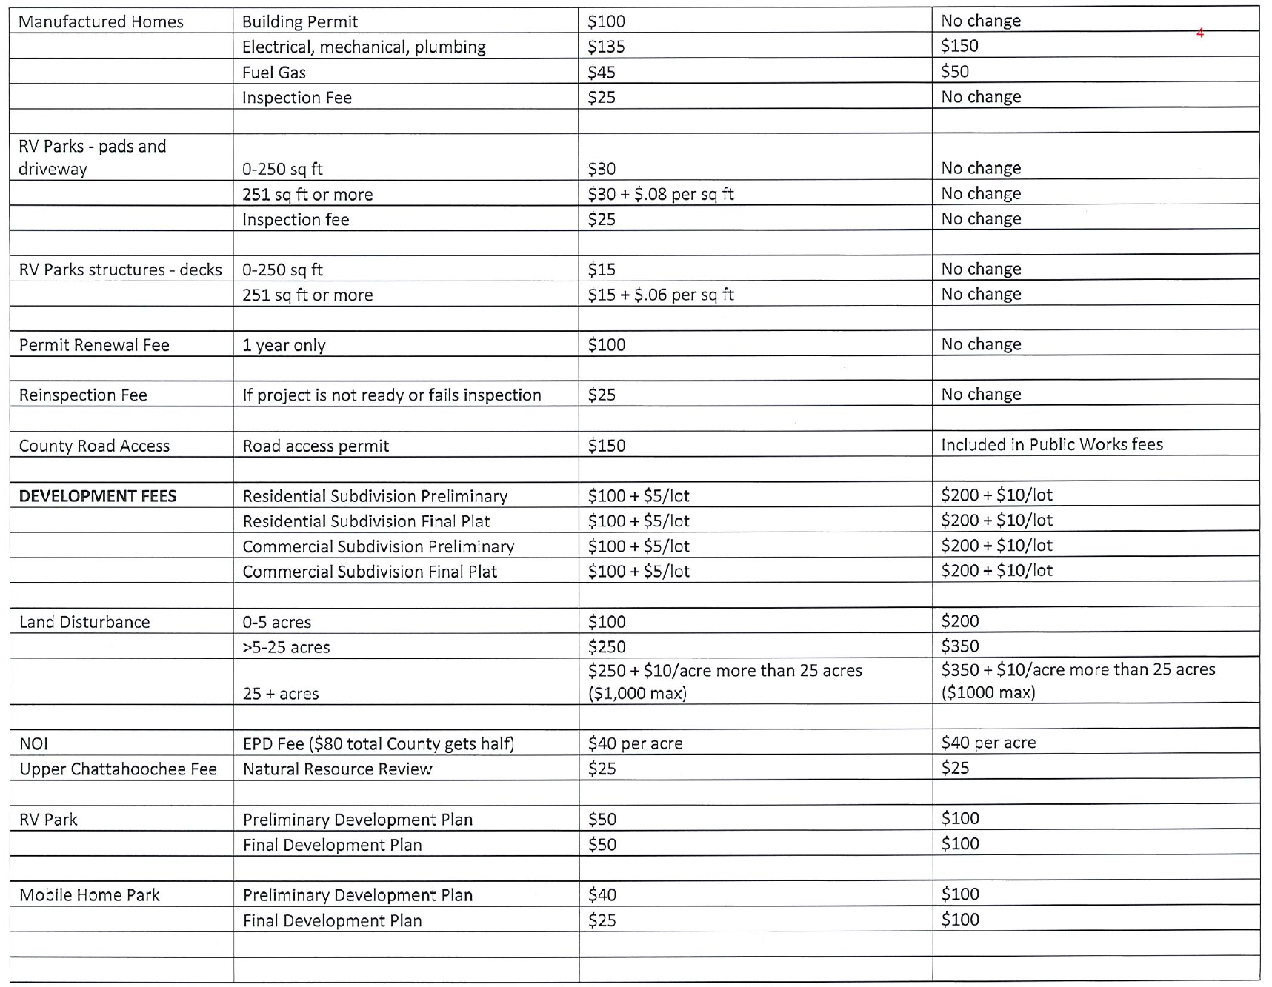
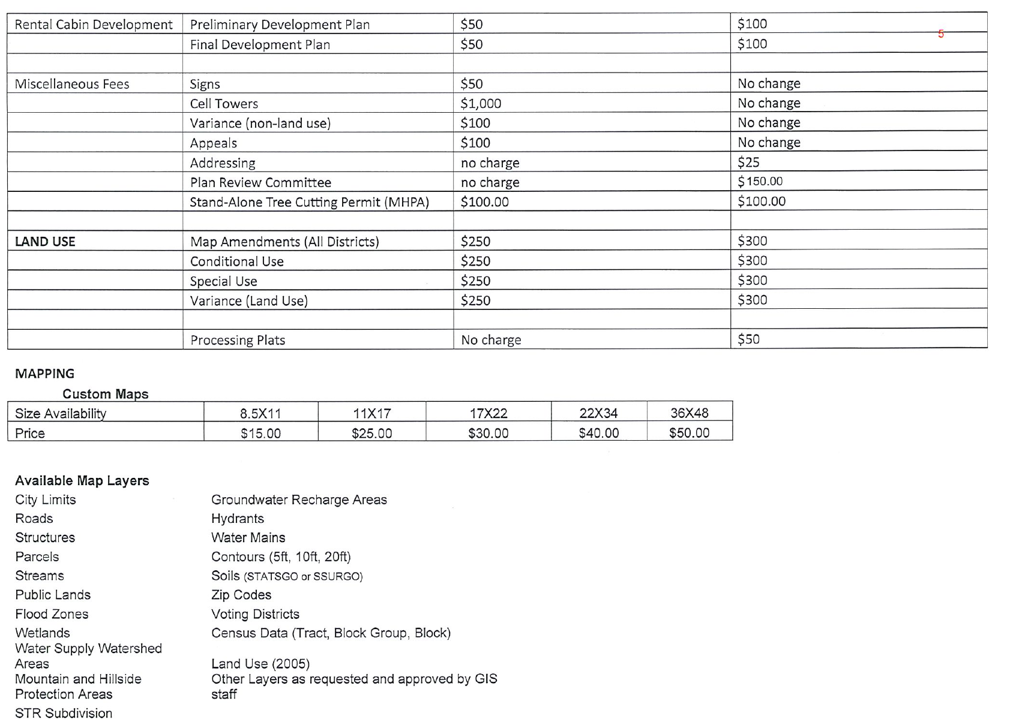
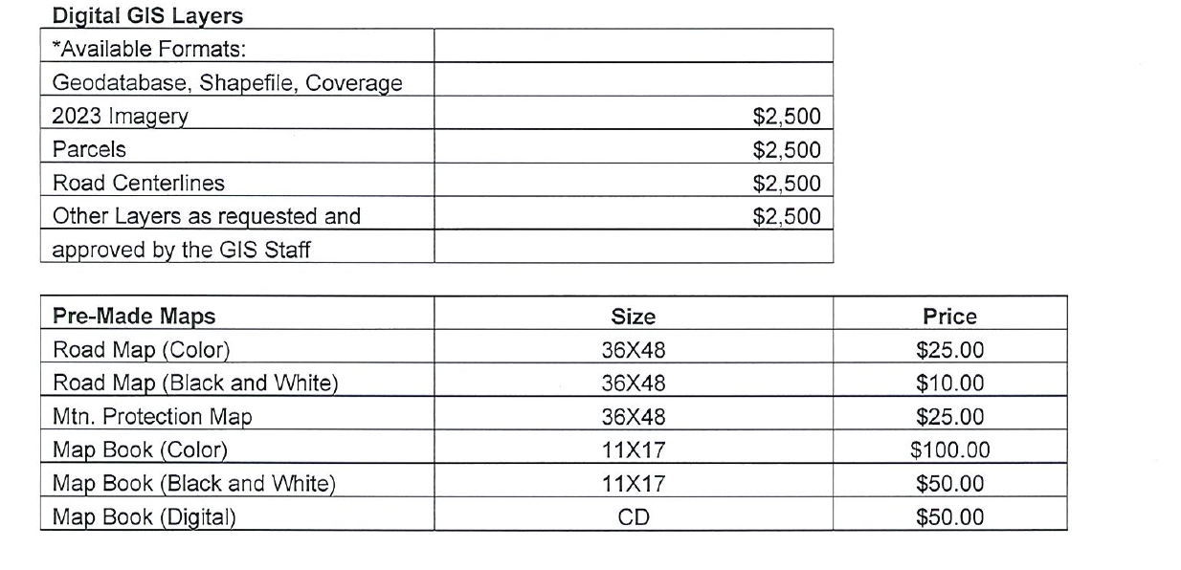
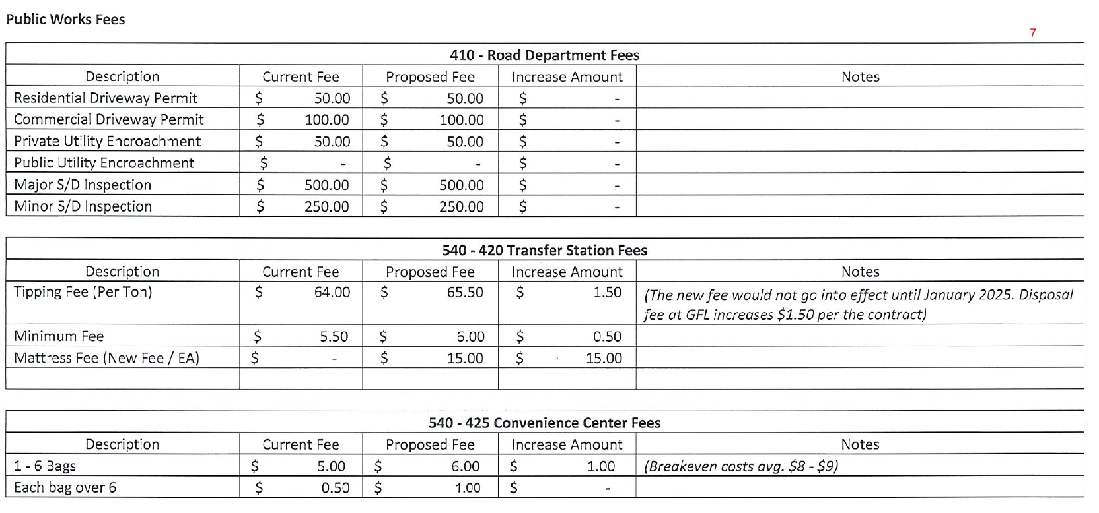
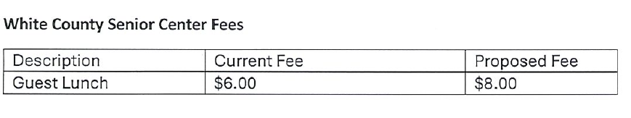
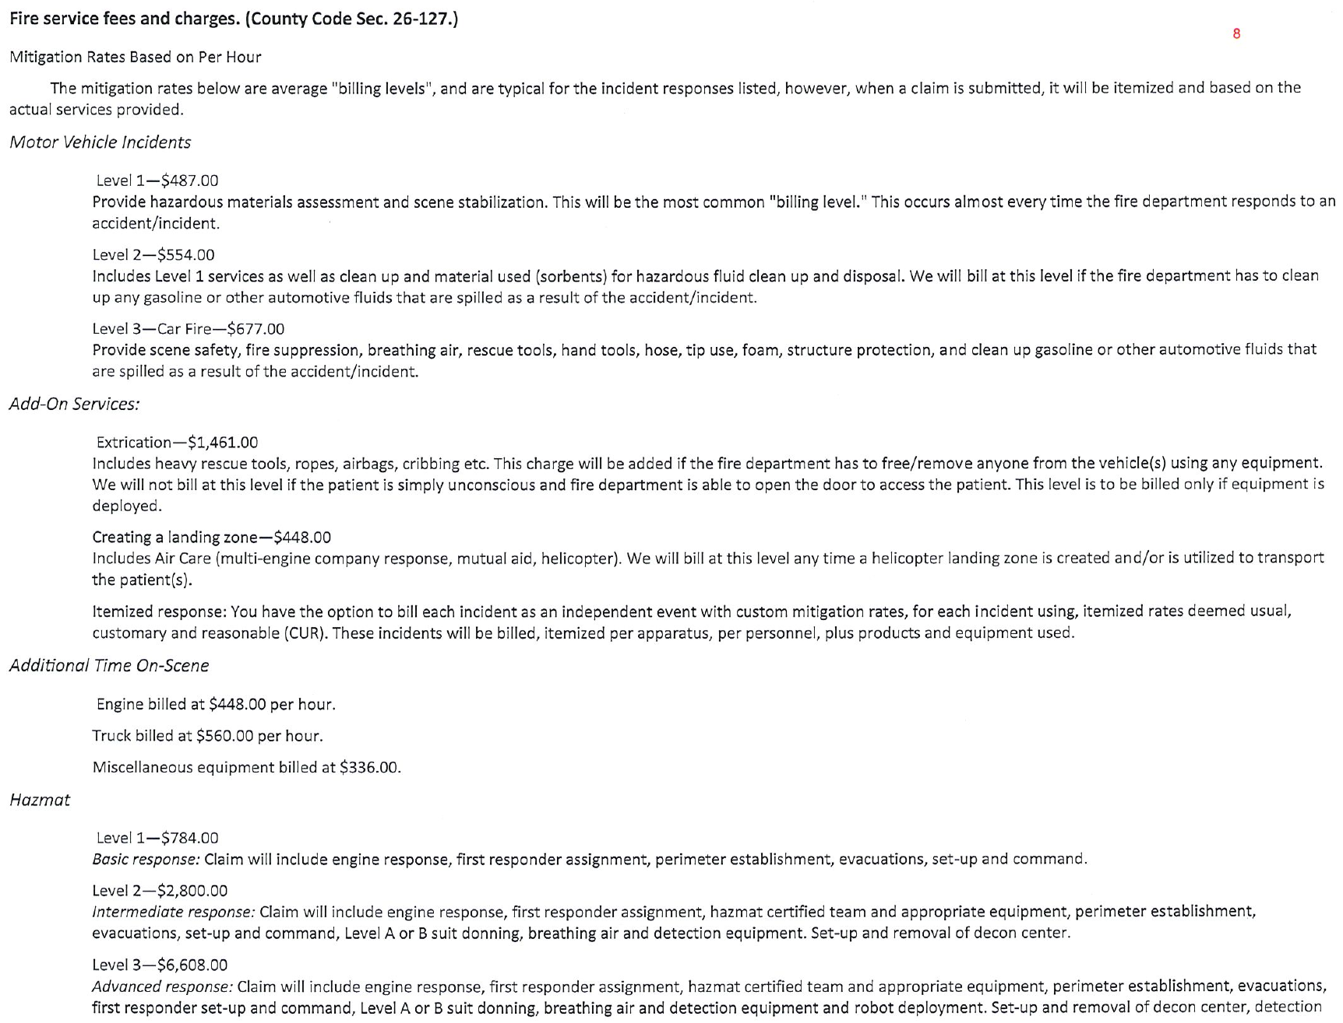
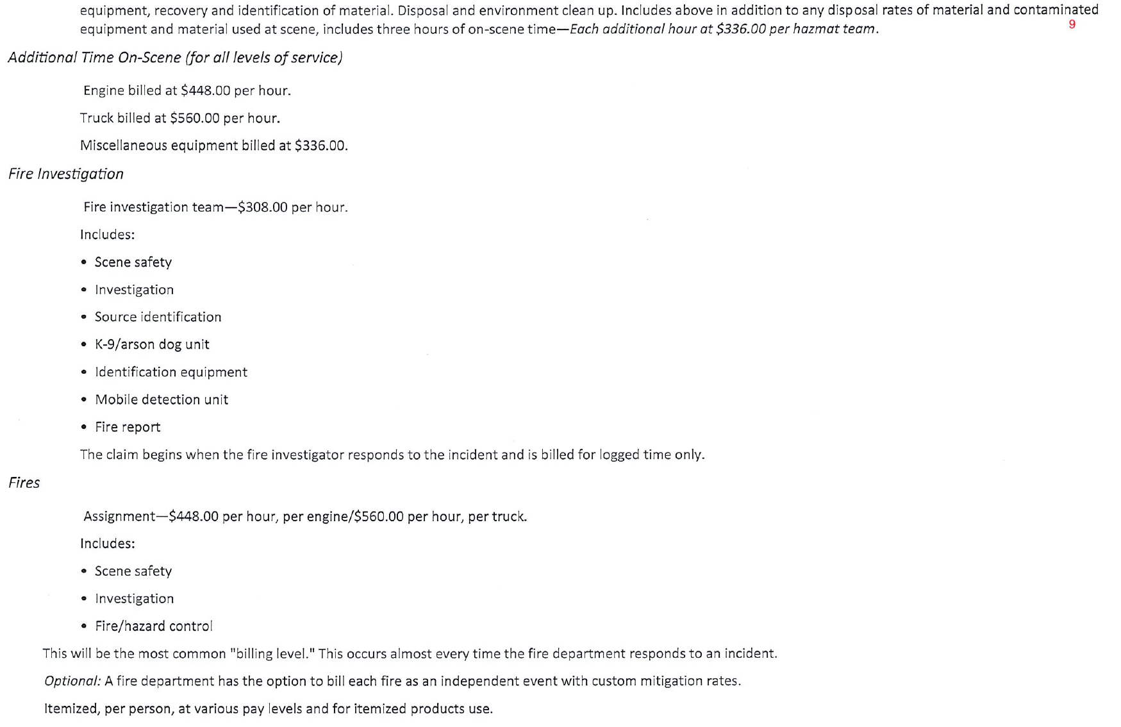
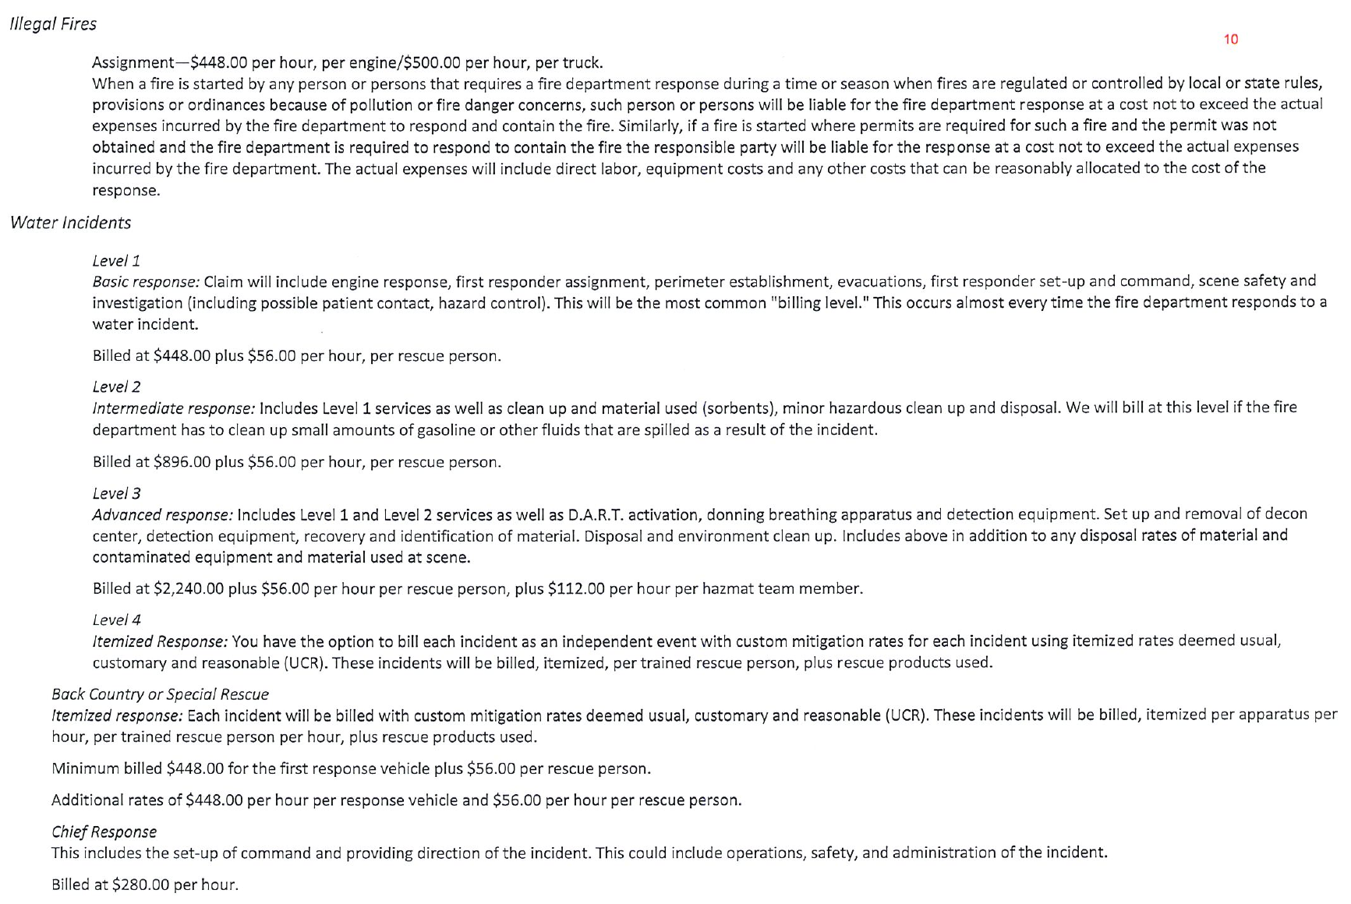
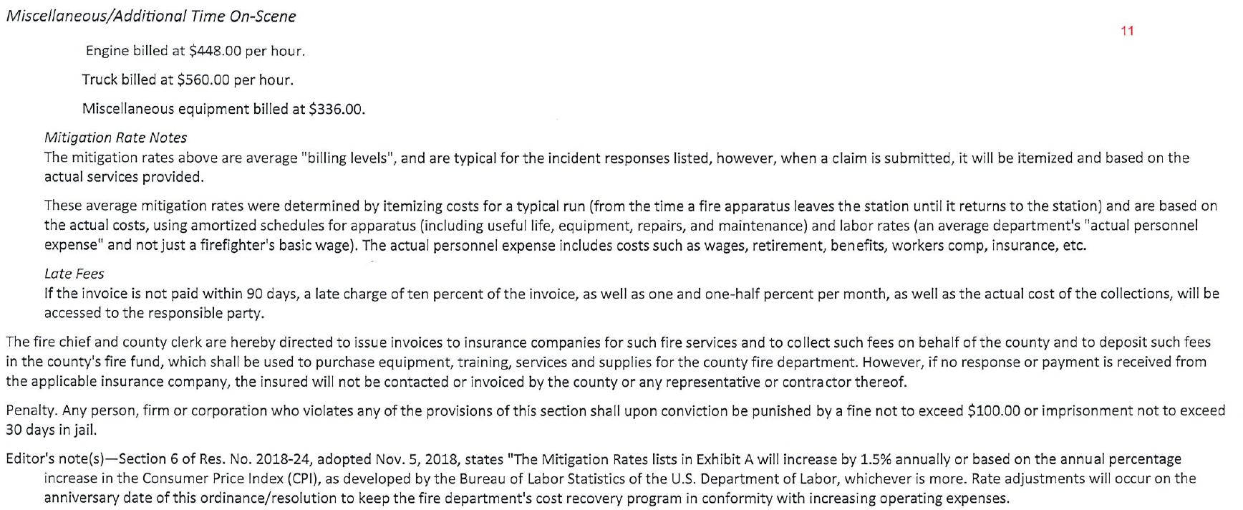
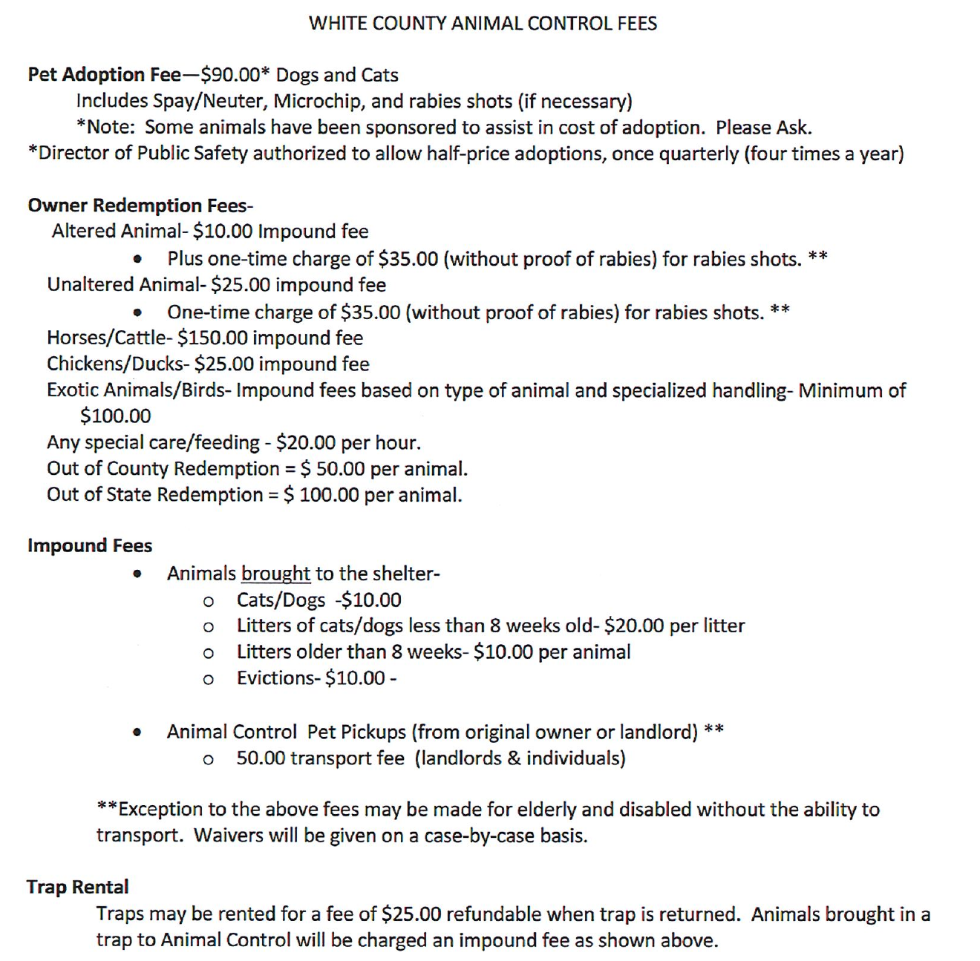
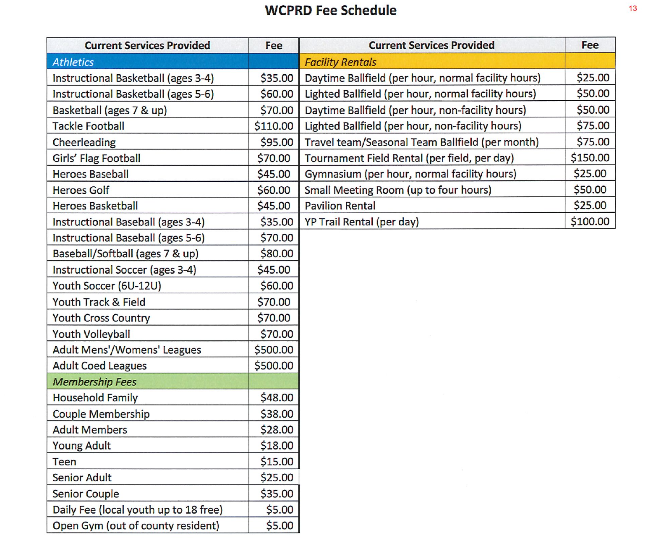
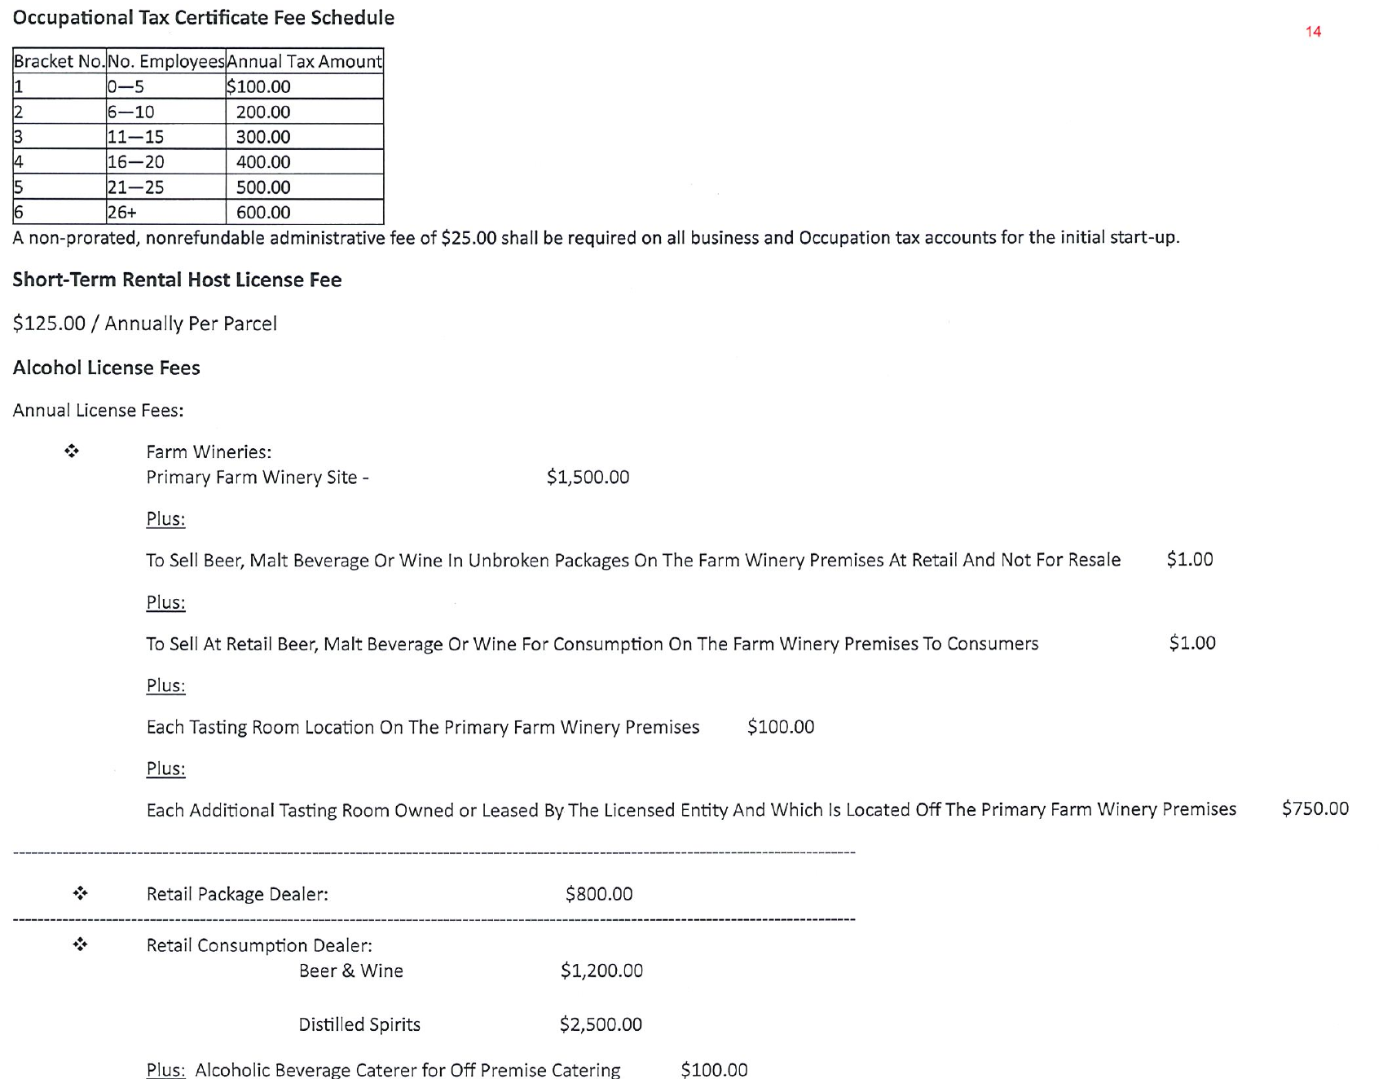
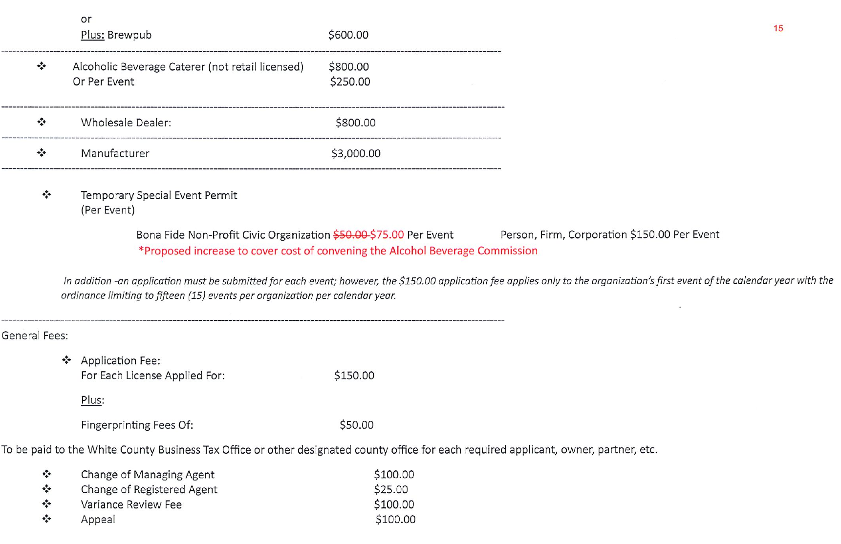
During County Manager Comments, Mr. Pittard praised the Elections Department for their work on the Primary Election and he congratulated Ms. Holly Witcher (wife of IT Director Joel Witcher) on being named the Georgia State Teacher of the Year.
During Commissioner Comments, Commissioner Goodger asked that the Board provide the go ahead to architect BCA Studio, (Jeff Croker) to prepare the construction documents for the library project so the information for the bidding of the project would be ready. He stated that $3,000,000.00 in state grant funds would be available for the project July 2024 and an announcement, concerning the $3,000,000.00 in federal congressionally directed spending which had been applied for, should be made in October 2024. Commissioner Nix said he would like to have more information on the formula used to calculate the 20,000 square feet on the project. Chairman Turner stated that this could be discussed at the next meeting.
Commissioner Bryant asked for an update on the status of the proposed Duncan Bridge Road Fire Station. Mr. Pittard and Mr. Murphy said there should be project documents available from Mr. Jeff Crocker next week.
Chairman Turner opened the floor for public comments.
Ms. Debora Palmer, 310 Bonnie Pearl Lane Cleveland, Ga stated that she had an opportunity to work in the recent elections and she complimented the staff of the Elections Office for all their hard work and dedication.
Upon a motion made by Commissioner Bryant, seconded by Commissioner Nix, there was a unanimous vote to adjourn the meeting.
Minutes of the June 3, 2024 Work Session & Regular Meeting were approved as stated this 24th day of June, 2024.
WHITE COUNTY BOARD OF COMMISSIONERS
s/Travis C. Turner
Travis C. Turner, Chairman

s/Terry D. Goodger
Terry D. Goodger, District 1

s/Lyn Holcomb
Lyn Holcomb, District 2

s/Edwin Nix
Edwin Nix, District 3

s/Craig Bryant
Craig Bryant, District 4
s/Shanda Murphy
Shanda Murphy, County Clerk

